 | Clinical | Pathology | Comments
Adenoma | ~Common incidental finding  ~Diagnosis restricted to low grade papillary lesions, 5 mm or less in size. | 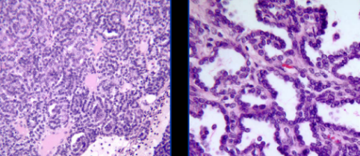
Oncocytoma | ~5% of kidney tumors in adults  ~ 2:1 more common in females  ~ usually asymptomatic | Gross: brown, central scar Micro: Uniform cells, pink cyto  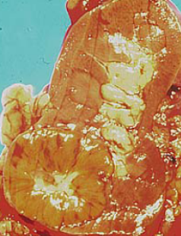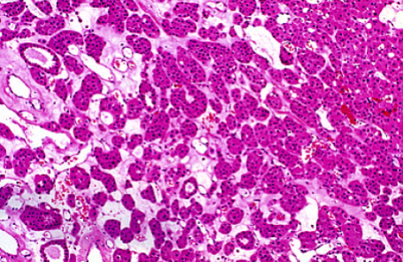
Renal Cell Carcinoma | ~2:1 more common in males  ~Associated conditions: Von Hippel Lindau, tuberous sclerosis, acquired cystic kidney disease, APCKD  ~Clear cell (3p del) most common – may be cystic, often necrosis  ~Clear cells caused by glycogen and lipid  ~sinusoidal vasculature | Gross: clear cell Micro: clear cell  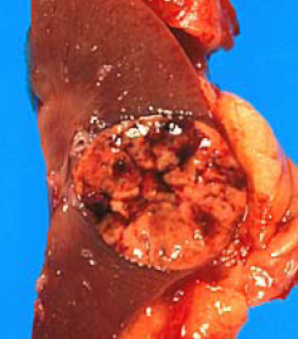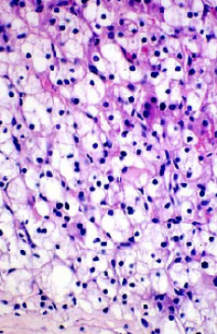 | Staging  T1a – confined to kidney, ≤4 cm, 95% 5 yr survival  T1b – confined to kidney, ≥4 cm, 95% 5 yr survival  T2 – confined to kidney, ≥ 7 cm, 90% 5 yr survival  T3 – perinephric fat, adrenal gland or renal vein invasion, 75% 5 yr survival  T4 – Invasion of Gerota’s fascia, 40% 5 yr survival  Distant metastases – 20% survival
Other kidney tumors | Angiomyolipoma  ~Triphasic, often occurs with tuberous sclerosis  Wilms tumor  ~Pediatric tumor  ~ triphasic: blastema, mesenchymal, epithelial | Angiomyolipoma Wilms Tumor  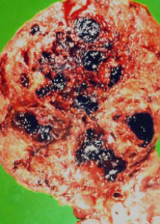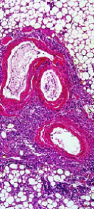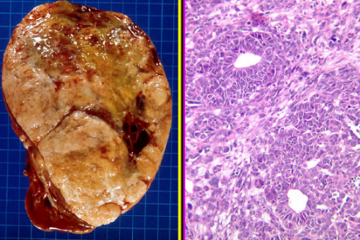 | ~Urothelial carcinoma of renal pelvis can present clinically as renal cell carcinoma  ~Assume all renal solid masses to be renal cell carcinoma until proven otherwise
Urothelial carcinoma | ~Typical presentation: hematuria + pain and irritative symptoms  Papillary – PUNLMP, low grade and high grade. Higher grade = more fused papillae  In Situ – urine usually contatins cells, high progression to invasive disease, when coexistant with papillary tumors, high risk of recurrences and progression  Non-papillary – majority come from in situ carcinoma, present with hematuria | Papillary  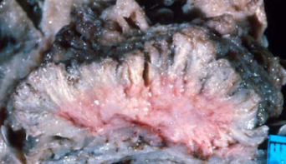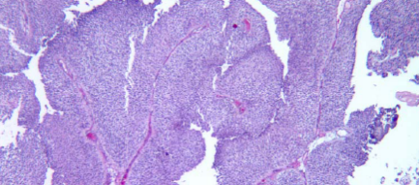  In Situ Non-papillary invasive  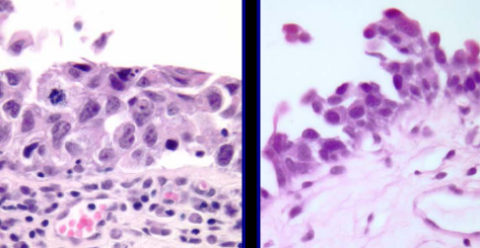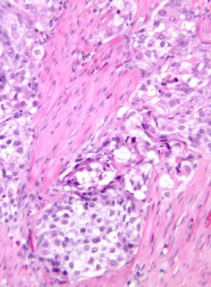 | ~Most important risk factor = smoking  Grading  Papillary –  Urothelial papilloma: fine fronds, normal ep  PUNLMP: fine fronds, little disorganization  Low grade: mild-moderate atypia, some mitotic figs  High grade: bizarre  ~20% ultimately will invade muscle  Non-papillary  T1: submucosa invasion  T2: muscularis invasion  T3: perivesical invasion  T4: adjacent structures  ** Once muscle is invaded, cystectomy is required.
Other bladder tumors | Squamus cell – common in areas where shistosomiasis is endemic  Adenocarcinoma – half arise in urachus, diagnosis of exclusion  Rhabdomyosarcoma – most common bladder cancer in kids | Squamus cell Adeno Rhabdomyosarcoma  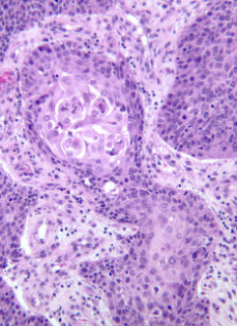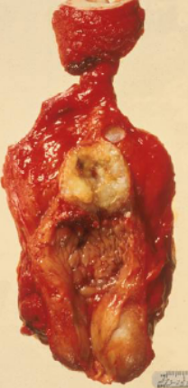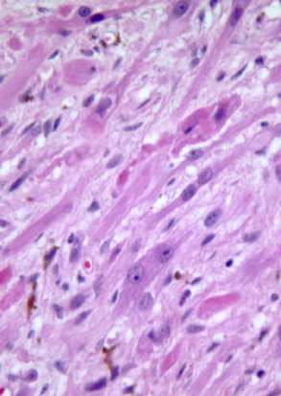
Prostate adenocarcinoma | ~Precursor: prostatic intraepithelial neoplasia  ~Many bone metastases  ~In kids, see rhabdomyosarcoma of the prostate | Gross: Micro:  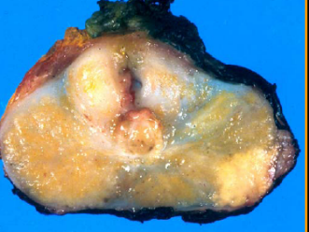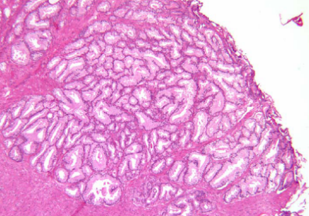 | Gleason grading  ~5 patterns, add the 2 most frequent  ~The lower the score, the higher the survival  ~Scores are based on growth patterns  TNM stage  T1: incidental  T2: confined  T3: Seminal vesicles or fat  T4: adjacent invasion

