 | Acute Tubular Necrosis | Acute Tubulo-interstital Nephritis | Acute pyelonephritis | Chronic pyelonephritis
Etiology | Two categories:  1. Ischemic injury – due to shock or hypotension caused by sepsis, burns, major surgery or hemorrhage  2.Tubulo-toxic injury – caused by toxic substance, like aminoglycosides, mercury, radiocontrast dyes. | ~Inflammation of the kidney interstitium which also affects the tubules.  ~Most often, drug induced: beta-lactams, sulfonamide, NSAIDS, diuretics  ~Systemic causes: group A strep, diphtheria, toxoplasma, legionnaire’s disease (NOT due to direct infection like AP) | Two routes:  1. Ascending – 95%, from UTI  2. Hematogenous – 5%, bacteremia  ~Obstruction of urine flow at any level, Vesicouretural reflux (perpendicular ureter, inflammation congenital), catheter, pregnancy, age/sex(babies, women, old men), immune dysfunction predispose | ~Caused by recurrent repeated bouts of AP, causing severe scarring of renal parenchyma, calyces, pelvis  ~Found in pts. with chronic urine reflux, recurrent UTI’s, followed by vesico-ureteral reflux, intrarenal reflux and AP.
Pathophysiological changes | ~Tubular epithelial cells with: impaired synthetic functions, decreased HEP stores, activation of destructive lysosomal processes  ~Cells often lose function without actually becoming necrotic…as long as the BM remains intact, regeneration is possible | ~Evidence for immunological basis: Pts often w/ history of hypersensitivity, TBM immune complexes sometimes seen, anti – tubular BM antibodies have been seen, T cell mediated damage shown. | ~Early: intense inflammatory interstitial and tubular infiltrate, glomeruli are relatively untouched  ~Grossly, see pus and inflammation | Scarred, asymmetric kidneys, one larger than other
Pathology | 1. Mild – loss of brush borders, vacuolization  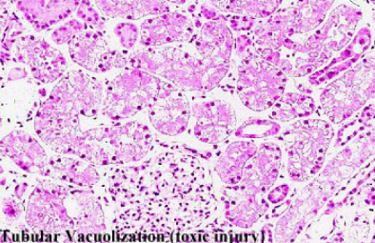  2. Severe – Necrosis, end up with bare BMs.  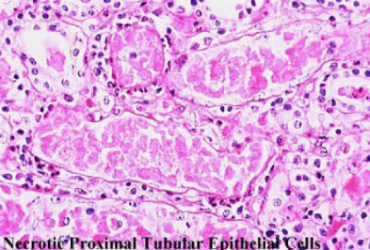  3. Regeneration w/ mitotic figures, simple ep.  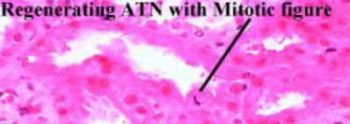  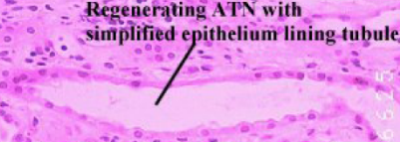 | 1. Inflammatory infiltrate  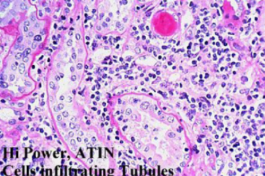  2. Presence of eosinophils  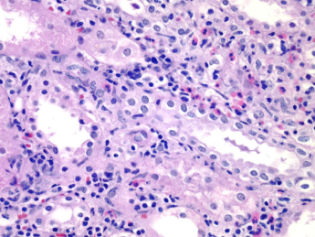  3. Normal glom surrounded by inflammation  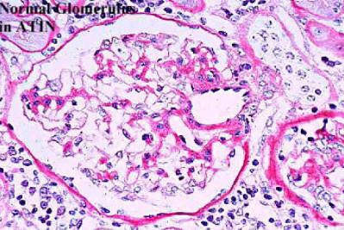 | 1. Streaks of infected tubules  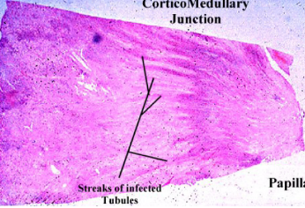  2. Pus and inflammation  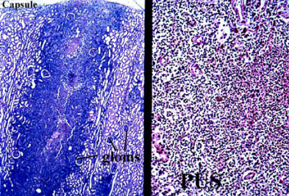  3. Papillary Necrosis  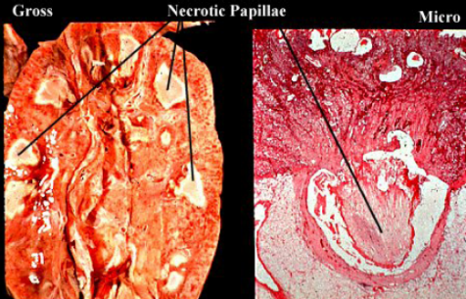 | 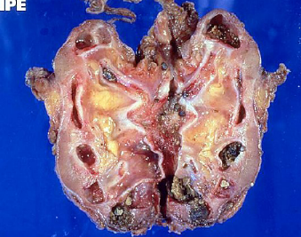
Prognosis | Often reversible, with regeneration and return of function if support is maintained (dialysis) |  | Good but can become chronic if repeated infections occur
Comments | ~3/4 of cases of acute renal failure  ~GFR reduced by: vasoconstriction, obstruction of tubules by casts, backleak of filtered urine into kidney vasculature and interstitium | ~Clinical presentation: features of hypersensitivity, like fever, hematuria, eosinophilia, pyuria, skin rash, mild proteinuria and eosinophilouria  ~Can cause acute renal failure | 3 complications:  1. Pyonephrosis – kidney = bag of pus  2. Perinephric abcess – infection spreads  3. Papillary necrosis – can slough off and cause obstruction. Usually occurs in presence of infection +obstruction to outflow+compromised blood flow (DM) | Gross diagnosis since microscopic findings are non-specific, such as glomerulosclerosis, interstitial fibrosis, tubular atrophy.

