ABC’s of Dermatology
1. Learn the classification of primary lesions
Macule | Non-palpable color change, <0.5cm
Patch | Non-palpable color change, >0.5cm
Papule | Solid Raised Lesion, <0.5cm
Plaque | Solid Raised Lesion, >0.5cm
Nodule | Solid, Deep, Domed Top, <0.5cm
Tumor | Solid, Deep, Domed Top, >0.5cm
Wheal | Solid, Superficial, Flat Top lesion without surface change – due to dermal edema
Vesicle | Raised, Fluid-Filled (clear), <0.5cm
Bulla | Large Vesicle, >0.5cm
Pustule | Vesicle with purulent fluid (PMN’s)

2. Learn the classification of secondary lesions
Erosion | Loss of superficial layer (epidermis)
Ulcer | Loss of deeper layers (dermis, subcu fat)
Crust | Dried Exudate
Fissure | Erosion or Ulcer that is linear
Excoriation | Scratching of skin, appears as a depression

3. Understand how the use of primary lesions, secondary lesions, color, distribution and configuration are used to classify skin diseases.
~Secondary skin changes
Scale | Shedding of Stratum Corneum (Thick scale – white, thin scale – yellow)
Desquamation | Peeling of Sheets of Stratum Corneum
Atrophy | Thinning of Skin – dermis (depressed skin) or epidermis (cigarette paper wrinkling)
Induration | Thickening of Dermis (edema, thickened collagen or inflammations
Lichenification | Thickening of skin – see lines in skin (like on palm normally) – due to chronic rubbing
~ Descriptions of color
Erythematous | Red (Inflammation, blood)
Blanching | Fades with pressure – port-wine stain
Telangiectasias | Dilated superficial blood vessels
Petechia | Speckled red to brown dots, non-blanching
Purpura | Large Petechia due to extravasated blood
~ Configuration
Annular | Ring with central clearing (Ring Worm)  *Nummular = coin-shaped  Active border with scale may be present
Arcuate | Form part of a circle
Serpiginous | Snake-like
Linear | Lesions form a line
Grouped | Lesions form clusters
Confluent | Small Lesions that grouped to form a larger lesion
Reticulated | Net-like appearance
~ Distribution
Acral | Bony Protuberances: hands, feet, elbows, knees (possibly mouth too)
Dermatomal | Follows along dermatome (herpes zoster)
Blaschkoian | Follows epidermal cell migration pattern
Generalized | All over body (drug causes)
Photodistributed | Sun-exposed Areas: Face, Neck, Hands
~ Inflammatory vs. neoplastic
Inflammatory | Multiple, Erythematous, Indistinct Margins
Neoplastic | Solitary, Non-Erythematous, Distinct Margins
~Disease categories
Papulosquamous | Plaques with Scale – thick, not itchy, distinct borders  - Psoriasis, Lichen Planus, secondary syphilis,
Eczematous | Plaques with Scale – Itchy, indistinct borders  - Atopic dermatitis, contact dermatitis
Granulomatous | Dermal Lesions – Inflamm., No Scale! (Infectious processes)  - Granuloma annulare, sarcoid, mycobacterial
Vesiculobullous | Blisters (Vesicles & Bullas) and Erosions  - Bullous pemphigoid (tense blisters), pemphigus vulgaris (flaccid)
Pigmentary | Variable Melanin – most macules/patches
Poikiloderma | Triad: Hypo/Hyperpigmentation, Atrophy of Epidermis, Telangiectasia
Alopecia | Hair Loss – Focal or Diffuse, Scarring or non-scarring

Structure and Function of the Skin
1. Understand the basic embryology of the skin
Ectoderm | Epidermis, piliary complex, eccrine glands, melanocytes
Mesoderm | Dermis, subcutaneous fat, blood and lymph vessels

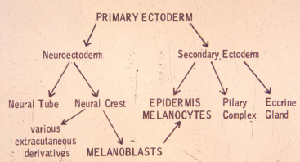

2. Understand the functions of the skin
- Thermal regulation
- Barrier function
- Immunologic defense
- Cosmetic
- Sensory

3. Understand the components of the epidermis
Stratum germanitivum (basal) | Can be flat, cuboidal or columnar. Usually contain a round or ovoid darkly staining nucleus with no nucleolus. Cells produce pedicels which increase contact area with basal lamina
Stratum spinosum (spinous = prickly = malphigian) | Connected via tightly bound desmosomal areas which are visible as “spines” when intercellular edema is present. Bulkier than basal cells with vesicular nuclei and one or more nucleoli
Stratum granulosum | Appear fusiform in vertical sections. Form keratohyalin granules which stain strongly with hematoxylin
Stratum lucidum (thick skin only) | Present in acral skin
Stratum Corneum | Lost nuclei, assume shape of pancakes with dense membranes.
Epidermal cellular composition:
Keratinocytes | Make keratin, an intermediate filament composed of an acid/basic heterodimer. High in cysteine so many disulfide bonds
Melanocytes | Clear, dendritic, Dopa +, S100+ cells situated along basal layer. Make melanosomes, which are clustered in Caucasians, distributed in darker skinned people.
Merkel Cells | Sparse cells with electron dense granules – tactile receptors
Langerhans cells | Clear, inconspicuous dendritic cells, S100 +, HLA-DR +, CD1+, stains with gold chloride. Found throughout the epidermis and contain Birbeck granules.

4. Understand the components of the dermis
- Collagen – primarily type 1, but type 4 in the basement membranes
- Elastic tissue – eulanin, oxytalan, mature fibers
- Reticular fibers
- Glyscosaminoglycans
- Cells: fibroblasts, mast cells, histiocytes
- Blood vessels and nerves

Glands:
Apocrine | ~Become functional during puberty, bacterial degradation causes odor, under adrenergic and humoral regulation.  ~Concentrated in axilla and genital regions  ~Begins with thin tube high in follicular wall, extends down into deep dermis and subcutaneous fat. Duct has 2 concentric layers of cuboidal cells.  ~Secretion via decapitation secretion | 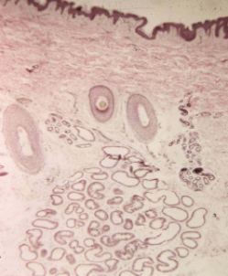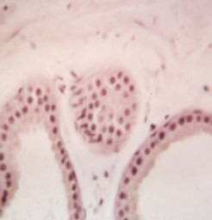
Eccrine | ~Originate independent of hair follicles  ~Acrosyringeum = portion that passes through epidermis  ~Inner secretory and outer myoepithelial layer, extends into deep dermis and subcutaneous fat.  ~ 2 layered dermal duct, coiled secretory duct  ~Innervated by acethylcholine, blocked by botox. | 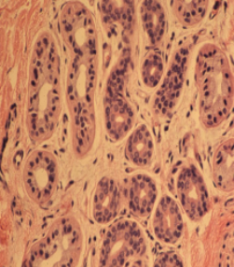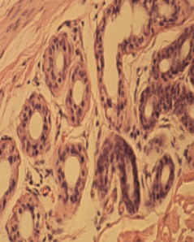

Hair follicles – 3 stages:
1. Anagen – period of hair growth, lasts 3-6 years
2. Catagen – period of hair follicle death
3. Telogen – Resting stage

Other dermal structures = Meissners corpuscles and Pacinian corpuscles

5. Understand the importance of proper skin biopsy
Currette | Not clinically useful
Shave | For exophytic and superficial lesions (ex – seborheic keratoses, dome shaped nevi, basal or squamus carcinoma (margins are unreliable)
Excisional | For large tumors
Punch | Dermal lesions and inflammatory processes (ex – nevi, basal and squamus cell carcinoma)

Extra – not in his objectives but he mentioned it might be important for test –
Manifestations of age related photodamage:
~ epidermal atrophy with hyperkeratosis
~ loss of epidermal rete ridge pattern
~ variable epidermal pigment
~ increased melanocyte numbers
~ destruction of elastic fibers

Introduction to Dermatopathology

1. Appropriate skin biopsy technique
General guidelines:
- Provide appropriate clinical history and description of lesion
- Use appropriate biopsy method
  - Punch – most common - +/- suture
  - Shave – very superficial, does not require suture
  - Excision – down to subcutaneous tissue, need to suture
- Site selection – try to get a new, fresh lesion, not one that has been mechanically destroyed by scratching.

2. General histologic pattern recognition for evaluation of a skin pathology specimen.
- Neoplasm vs. Inflammatory process
  - Neoplasm – benign vs. malignant
  - Inflammatory – what tissue pattern?

3. General criteria for determining a benign vs. malignant neoplasm
Benign → | Circumscribed | Symmetric | Well-differentiated | Uniform Nuclei | Very few mitoses | No inflammation
Malignant → | Poorly-circumscribed | Asymmetric | Poorly- differentiated | Nuclear pleomorphism | Many mitoses | Inflammation

4. Recognition and definition of basic tissue inflammatory patterns
- Perivascular inflammation with epidermal changes
  - Spongiotic (like eczema)
    - Variable epidermal acanthosis with variable spongiosis (epidermal edema)
    - Exocytosis of inflammatory cells into the epidermis
    - Dermal perivascular lymphocytic infiltrate
  - Psoriasisiform
    - Regular epidermal hyperplasia
    - Suprapapillary thinning of epidermis
    - Dilated papillary dermal blood vessels
    - Mounds of perakeratosis containing neutrophils
  - Lichenoid
    - Hyperkeratosis
    - Irregular epidermal hyperplasia
    - Band like lymphocytic infiltrate
    - Hydropic changes of the basal cell layer
    - Cytoid bodies
- Primary dermal inflammation
  - Perivascular (toxic dermatitis)
  - Nodular and diffuse
- Bullous dermatoses
  - Intraepidermal bullae
  - Subepidermal bullae
- Vasculitis – inflammation of blood vessels
- Panniculitis – inflammation of subcutaneous fat
- Folliculitis – inflammation of hair follicles
5. Features of warts, psoriasis, lichen planus and discoid lupus erythematosus
- Warts (Verruca Vulgaris)
  - Epidermal hyperplasia with acanthosis, papillomatosis, hyperkeratosis
  - Hypergranulosis
  - Koilocytes – perinuclear clearing in granular cell layer due to accumulation of viral particles
  - Focal parakeratosis and hemorrhage
- Psoriasis
  - Regular epidermal acanthosis
  - Suprapapillary thinning, exocytosis of neutrophils
  - Dilated papillary capillaries
  - Mounds of parakeratosis containing neutrophils (Munro microabscess)
- Lichen Planus
  - Hyperkeratosis
  - Irregular epidermal acanthosis
  - Band-like lymphocytic infiltrate – superficial
  - Hydropic degeneration of basal cell layer
  - Cytoid bodies
- Discoid Lupus Erythematosus
  - Epidermal atrophy
  - Hydropic degeneration of basal cells
  - Superficial and dep lymphocytic inflammation
  - Atrophy of hair follicles
  - Thickened basement membrane
Melanoma and Benign Melanocytic Lesions
**theres lots of other info in her notes, so I would probably read through them**
1. Know ABCDE
- Asymmetry
- Border irregularity
- Color variation
- Diameter (≥6 cm)
- Evolution – change in size, shape, colors, bleeding, crusting, etc.
2. Know pigmented lesions and genetic syndromes
- NF1 – café au lait macules
- Peutz Jeghers – lentigenes + intestinal polyps + tumors (triad)…lentignes are often in oral mucosa
3. Appropriate biopsy techniques
- Shave/snip – used for skin tags, superficial things
- Saucerization – used to biopsy into dermis, used to rule out BCC
- Punch – deep into dermis and fat, for inflammatory disorders or deep tumor growths
- Incisional wedge – used for inflammatory disorders in the fat
- Full excision with margins – used to remove cancerous/suspicious growths
4. Types of melanoma in different populations
- Nodular – in males more than females
- Lentigo maligna – in older people
- Acral lentiginous – African Americans ≥ asians≥whites
- Superficial spreading malignant melanoma – 50-75% of total cases, typically diagnosed at age 30-50.Typically on LE of female, trunk of male, often arises de novo.

Pathophysiology of melanoma and treatment options

1. Identify the etiological factors of melanoma and describe the complexity of UV light role in tumorigenesis
- Risk factors:
  - UV light
    - A clear association has only been shown with one type of melanoma – lentigo malignant melanoma.
    - Relationship of UV light to other melanomas is entirely circumstantial, with a relationship to latitude being the strongest evidence.
    - Findings that question a substantial role: presence of melanomas in sun protected areas, presence in utero and in young children, absence in albinos who had other skin cancers, latitude also has relationship to ovarian and colon cancers (clearly independent of the sun), recall bias.
  - Immunosupression
  - DNA repair mechanism defects
  - Tissue microenvironment
  - Mutations in key signaling genes
  - Chromosomal abberations
  - Mobile genetic elements

2. Describe melanoma pathophysiology and identify anatomical, physiological and genetic factors that impact pregression and clinical phenotype
- Starts with a malignant transformation of benign melanocytes
  - Radial growth phase – extension upwards into epidermis – in situ carcinoma
  - Vertical growth phase – invade into the dermis and are metastatically competent
- Metastases can occur through both lymphatic or vascular route.
  - Lymphatic – trapped in first draining (=sentinel) lymph node. ID this node by injection vital blue dye at the tumor site.
    - SLN -: 2% chance of other lymph nodes being affected
    - SLN +: 20% chance other nodes are affected
    - Rarely, emboli can skip SLN, and form distant nodal metastases.
  - Hematogenous – circulation is hostile so few cells survive to establish metastases
    - # of emboli in blood is proportional to tumor size, duration, and development of necrotic areas within the tumor.
    - More cells released = higher chance of metastatic disease
- “Seed and Soil” – only metastasize to certain anatomical places: skin (main), CNS, LN, GI, lungs, liver bone. The seed must match the soil.
- Metastatic heterogeneity is seen, partially due to metastases of metastases.
- Tumor progression – driven by acquired genetic alterations due to high rate of spontaneous mutation.
3. Describe the extent to which genetics plays a role in melanoma pathogenesis and ID genes that are implicated in this process
- Familial melanoma – defined as families with at least 3 members affected, rather then technical definition which requires an actual mutation to be found.
- Hereditary melanoma predisposition –
  - About 10% of cases are hereditary
  - Suspect if family members with: uveal melanoma, pancreatic cancer, CNS tumors
- Implicated genes:
  - Familial melanoma susceptibility genes –
    - CDKN2A (p161NK4a, p14ARF)
    - CDK4
    - Putative – BRAF
  - Genes underlying other syndromes but confer melanoma risk
    - RB1, TP53, NF1, XP, WRN, BRCA2
4. Describe the cellular function of CDKN2A, CDK4 and BRAF, and understand the implications of these genes on melanoma
- CDKN2A (tumor suppressor gene) – chromosome 9p21, 4 exons (1beta, 1alpha, 2 and 3)
  - Encodes 2 proteins through use of alternative promotors (p16(1α, 2, 3) and p14ARF(1β, 2, 3))
    - P16 – arrests cell in G1 by inhibiting cyclinD-CDK4/6 complex, which prevents Rb phosphorylation…hypophosphorylated Rb represses transcription, blockingG1 to S transition
    - P14ARF – enhances apoptosis, blocks oncogenic transformation by blocking degradation of p53 by HDM2.
  - Many mutations affecting p16 also affect p14, but p14 mutations alone have been described
  - Most mutations fall in 1α or 2 – 3 has never been described
- CDK4 (oncogene)– a mutation here generates resistance to p16 inhibition.
- BRAF – proto-oncogene located on 7q34.
  - Signals through RAS-RAF pathway which regulates cell growth
  - Pathway is constitutively active in melanoma and other cancers
  - Altered in the majority of sporadic melanoma
  - Hotspot mutation – V600E mutation
    - Occurs early in tumorigenesis but is not sufficient for development of melanoma
      - Might be important for melanocyte transformation but not metastasis.
  - Cannot serve as prognostic marker for melanoma – no correlation btw. BRAF activation and Breslow thickness, clinical stage or clinical outcome.
5. Understand the clinical significance of the genetic test for CDKN2A in melanoma patients and in their relatives and describe the clinical aspects of BRAF activation.
- CDKN2A predisposition testing
  - Only offer if: strong family history, early age of onset, test that’s easy to interpret, results will influence medical treatment
  - Testing is available but currently recommended against –
    - False sense of security if test negative.
  - Factors which impact likelihood of detecting mutations with test – family history, geographical variation (highet in Australia, low in Europe), multiple melanomas in a pt. w/o family history, pancreatic cancer in close relative of melanoma pt.
  - Factors which don’t impact likelihood of detection – atypical nevus syndrome, early age of onset outside of family history.
  - Test interpretation
    - Positive test
      - Increased risk of developing melanoma compared to general pop.
      - Mutation defines mutation for rest of family
      - Non-carrying relatives still comprise 10% of melanomas, thought to be due to environmental factors.
      - In unaffected person in high risk family –
        - Future risk is estimated by penetrance
        - Estimates vary widely with geography
    - Negative test
      - May be sporadic melanoma
      - Unlikely that you would test other family members
      - May be hereditary but a diff. gene
      - Unaffected person in high risk family with no mutation ID’d yet –
        - Steer away from false sense of security
        - Can’t rule out mutation in his fam – maybe he’s not a carrier
        - Might be a mutation in a different gene
        - Maybe no single gene is transmitting risk, but a bunch together
  - Validity of testing
    - Sensitivity and specificity are difficult to quantitate, b/c sporadic cases can contaminate high risk families
    - Penetrance varies geographically
    - Mutation detection strategy affects validity of test
- Therapeutic BRAF
  - Inhibitors of RAS-RAF pathway intermediates are currently being tested for anti-cancer use.
6. Describe the factors that determine melanoma prognosis and AJCC staging
- In absence of distal metastases – regional LN involvement is most important
- If no LN involvement, Breslow thickness is most important.
- Bad prognostic factors: increased granular layer thickness, ulceration, high mitotic index, sparse lymphocytic host response, vascular invasion, histological signs of tumor invasion, tumor location on head, neck, trunk, old age, male
- Good prognostic factors: increases melastatin (=less metastases and longer survival), presence of tumor infiltrating T lymphocytes in VGP.
- AJCC staging
Stage | Description
0 | In situ (in epidermis only)
1A | ≤1 mm, papillary dermis only
1B | ≤1 mm, invades reticular dermis OR 1A +ulceration
2A | 2-4 mm OR 1B + ulceration
2B | ≥4 mm OR 2A + ulceration
2C | 2B + ulceration
3 | Regional LN metastases
4 | Distant LN, skin, or organ metastases
7. Describe the surgical approach and latest innovations in melanoma treatment
- Sentinel lymph node dissection
  - If positive for melanoma, do a complete lymphadenectomy
  - In 1-4 mm melanomas, dissection improves survival - good diagnostically and therapeautically
- Surgical approach – Excise melanoma with following margins – Stage 0 (.5 cm), Stage 1 (1 cm), Stage 2-4 (2 cm).
  - Biopsy SLN, and do regional lyphadenectomy if positive.
- Chemoprevention – good for pt’s with dysplastic nevi, esp. if family history of melanoma or previous melanoma.
  - Potential agents – statins, imiquimod, retinoids, COX inhibitors, prillyl alcohol
  - Most promising = lovastatin. Targets RAS signaling, apoptosis and cholesterol levels.
- Immunotherapy – IFN-α
- Vaccines – use tumor antigens, whole tumor cell, or dendritic cells pulsed with antigens
  - No real meaningful clinical responses have been shown
- Toll-like receptors are present on dendritic cells, activate immune response
  - Imiquimod = TLR agonist. May also enhance vaccine potency
- CTLA4 antibody blockade – CTLA4 attenuates T cell function, so block it.
- Gene therapy – not dependent on host immune status. Tailor therapy to patient.

Papulosquamus Diseases
1. Understand why certain skin diseases are grouped into the papulosquamus section.
- Features of this group –
  - Epidermal involvement causes scaling (hyperkeratosis) and sharp margination
  - Dermal involvement causes erythema from vessel changes and thickness from cellular infiltrate
2. Differentiate psoriasis from lichen planus.
 | Psoriasis | Lichen Planus
Clinical | Plaques – beefy red, infiltrated, silver scale, sharp border  Distribution – extensor surfaces, scalp, nails  Auspitz’s sign – bleeding on removing scales  Koebner phen. – “isomorphic response”  Arthritis | Flat-topped (lichenoid), violaceous, polygonal papules  Distribution – volar (wrists), mucous membrane  Koebner phenomenon – isomorphic response  Very pruritic
Etiology | ~Multifactorial, probably genetically abnormal control mechanism for keratinocyte proliferation  ~Decreased epidermal transit time  ~Decreased G2 in cell cycle | Spontaneous cases – autoimmune?  Drug associated – gold, arsenic, INH, PAS
Pathology | ~Acanthosis, with elongation of rete ridges  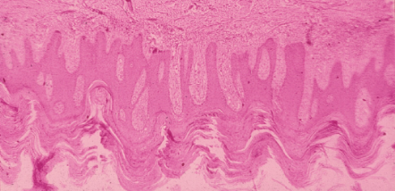  ~Elongated, edematous and club shaped dermal papillae with dilated capillaries  ~thin suprapapilarry plate of epidermis  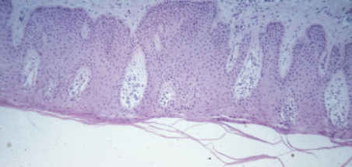  ~confluent parakeratosis, sometimes orthokeratosis  ~Munro’s microabcesses – PMNs, early lesions only  ~Superficial perivascular infiltrate (lymphocytic)  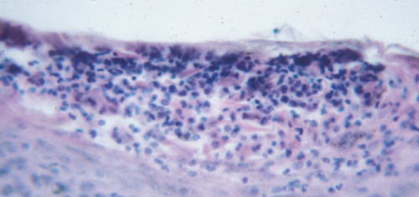 | ~orthokeratosis (increased granular layer)  ~irregular acanthosis (saw tooth appearance)  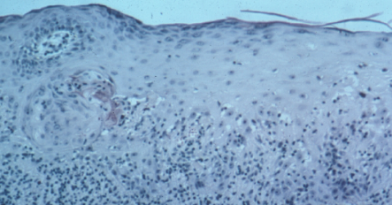  ~vacuolar degeneration of the basal cell layer  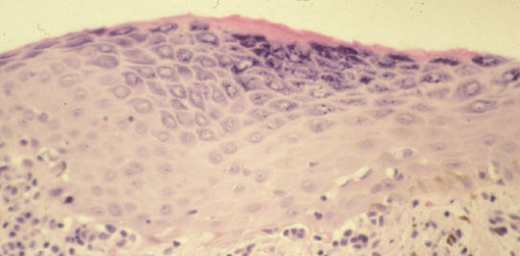  ~band like infiltrate hugging E-D junction  ~if drug induced, may see eos.
Treatment | ~Topical corticosteroids  ~Goeckerman regimen = coal tar + UV light  ~Systemic – MTX, hydroxyurea  ~PUVA  ~UVB  ~biologics | ~Corticosteroids – systemic or topical  ~Topical retinoids

3. Review the treatment options for tinea corporis, seborrheic dermatitis and tinea versicolor.
Tinea corporis | Topical – tinactin, miconazole, clotrimazole, haloprogin  Systemic – griseofulvin, ketoconazole
Seborrheic dermatitis | Hydrocortisone (low potency topical corticosteroids)
Tinea versicolor | Selenium sulfide, sodium hyposulfate, antifungals

Vesiculobullous Diseases: From Benchtop to Bedside
1. Learn to use indirect (serum) and direct (skin) IF microscopic staining patterns to clinically diagnose and help treat patients with vesiculobullous skin diseases.
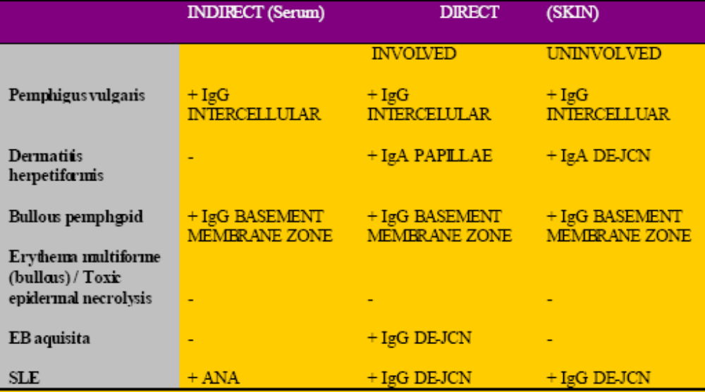

Treatment strategies –
PEMPHIGUS VULGARIS BULLOUS PEMPHIGOID
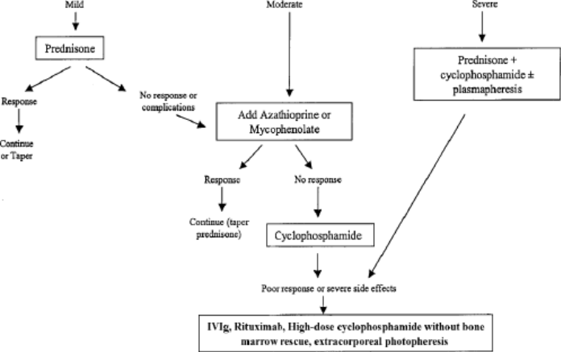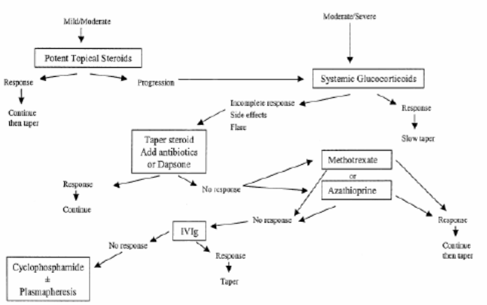
2. Learn to ID and treat clinical drug eruptions – reactions in skin and the drugs that induce acute and life-threatening systemic reactions in patients.
Reaction | Drugs
Type 1 anaphylactic (IgE mediated hypersensitivity, mast cell degranulation – itchiness) | NSAIDS (cause urtiaria, EM, maculopapular, purpura/vasculitis, photosensitivity, exfoliative dermatitis, erythema nodosum)
Type 2 cytotoxic(IgG and FcR, FcR dependent cell destruction, blood dyscrasia)
Type 3 (IgG and complement or FcR, immune complex deposition, vasculitis)
Type 4a (Th1, monocyte activation, eczema) | captopril
Type 4B (Th2, eos, macupapular and bullous exanthema) | Furosemide, many others
Type 4C (CD4 or CD8 mediated cell killing, maculopapular, eczema, bullous or pustular exanthema)  - Erythema multiforme  - Severe eruption  - Lupus-like syndrome | Anticonvulsants (phenytoin, carbamazapine, lamotrigine) – will cause urticaria, maculopapular, erythroderma, exfoliative dermatitis, EM/TEN, porphyria cutanea tarda  Herpes, fungi, barbituates, NSAIDs, penicillins  Sulfonamides  Minocycline, hydrochlorothiazide, hydralizide, statins, terbenafine, procanamide
Type 4D (T cells, neutrophil recruitment/activation, pustular examthema)

Stevens-Johnson Syndrome/ Toxic epidermal necrolysis  (EM is more caused by infections, SJS and TEN by drugs) | Antibiotics (sulfonamides, aminopenicillins, quinolones, cephalosporins)  Anticonvulsants, NSAIDs, allopurinol, cortisone
Lupus-like syndromes | Minocycline, terbanifine,  Hydrochlorothiazide can unmask subclinical SLE
Acute generalized exanthematous pustulosis | Antibiotics (macrolides and cephalosporins), NSAIDs
DRESS (drug induced hypersensitivity) | Anticonvulsants(phenytoin)

Lab studies to do in drug reactions: CBC & diff, eo count, SMA12, urinalysis, ANA, skin biopsy
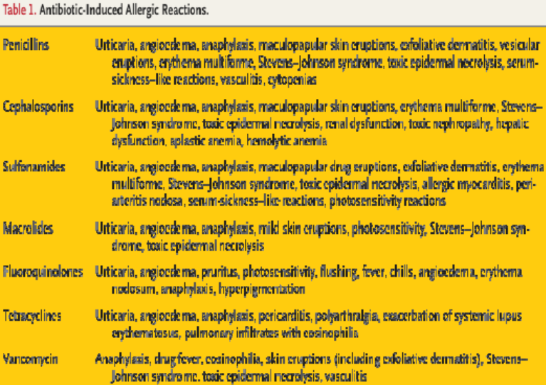
1. Which of the following pharmacologic drugs are most commonly used to treat the majority of vesiculobullous diseases?

A. Cytotoxic-immusuppressives like azathioprine, chlorambucil, cyclophosphamide and methotrexate
B. IV IgG
C. Glucocorticoids – prednisone and methylprednisolone
D. Sulfones - dapsone
E. Anti-rejection drug - mycophenolate mofetil

2. Matching: Match the cutaneous immunofluorescent pattern with the vesiculobullous disease. Each answer may be used only once.

A. No pattern found
B. dermoepidermal junction - IgG
C. papillary pattern – IgA
D. basement membrane zone pattern -IgG
E. intercellular pattern – IgG

_A__ Erythema multiforme/toxic epidermal necrolysis
_B__ Epidermolysis bullosa aquisita & SLE
_C__ Dermatitis herpetiformis
_D__ Bullous pemphigoid
_E__ Pemphigus erythematosus

3. Matching: Match the drugs with the induced-cutaneous reaction in skin. Each answer may be used only once.

A. minocycline, hydrochlorthiazide, hydralazine and procaineamide
B. furosemide & celecoxib
C. penicillin, sulfa, allopurinol, and carbamazepine
D. nsaids
E. phenytoin

_B___ Bullous pemphigoid
_C___ Erythema multiforme /Toxic epidermal necrolysis
_D___ Acute generalized exanthemic pustular eruption
_E___ DRESS syndrome
_A___ Subacute lupus erythematosus
4. Vancomycin can cause which of the following types of drug-induced eruptions?
A. Pityriasis rosea, psoriasis and tinea corporis
B. Acne vulgaris, acne fulminans and conglobate acne
C. Exfoliative dermatitis, generalized erythroderma, and erythema multiforme
D. Acute generalized exanthemic pustular eruption
E. Systemic lupus erythematosus, bullous pemphigoid, and dermatitis herpetiformis

Non-Melanoma Skin Cancer
Actinic Keratosis  premalignant epidermal condition in sun-exposed areas  erythematous ill-defined papule or plaque w/ crusting or scale  histologically see dysplastic keratinocytes w/ mitotic figures in epidermis  tx w/ liquid nitrogen or topical 5-FU (can be painful) or diclofenac | 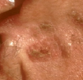 | Bowen’s Disease  SCC in situ = intraepidermal carcinoma; can progress to SCC; does not invade dermis  poorly-defined, red plaque w/ scale  sun-exposed areas or abs, groin, thighs of black people  assoc w/ arsenic exposure  tx w/ cryosurgery, excision, curettage, electrodessication | 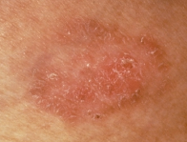
Cutaneous Horn  thickly hyperkeratotic papule or plaque; beware, can be via wart, seborrheic keratosis, actinic keratosis, keratoacantoma, SCC | 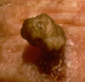 | Keratoacanthoma  rapidly growing, benign tumor simulating squamous cell; goes away on its own in 4 mo.  keratotic, crateriform plaque or nodule w/ central ulceration  found on sun-exposed areas in old white men  tx w/ excision, curettage, electrodessication, intralesional methotrexate | 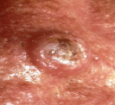
Basal Cell Carcinoma  most common malignancy; risk of metastasis is very low, but can do extensive local invasion  nodular type most common = pearly flesh-colored plaque w/ telangiectasias w/ central ulceration and rolled border; occur on face  superficial type = fixed, non-blanching, erythematous plaque; show on chest and back  Micronodular, infiltrative, morpheaform types have lots of fibrous stroma, look like a scar  tx of choice = Mohs surgery | 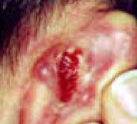 | Squamous Cell Carcinoma  2nd most common skin ca, nests of cells invade the dermis; can metastasize (esp. if on eye,lip,anus,genitals or if arose de novo rather than from Bowen’s disease)  Marjolin tumors = arise within scars or chron. ulcers  keratotic, indurated plaque that is exophytic w/ central ulceration  tx w/ Mohs, radiation, excision, cryo, etc. | 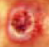

1. The student will understand how to recognize basal cell carcinoma and squamus cell carcinoma by morphologic features
- Basal Cell Carcinoma –
  - Types: superficial, nodular/micronodular/noduloulcerative, sclerotic/morpheaform/infiltrating, fibroepithelioma of pinkus, pigmented
  - Appearance – rolled border, on histology, see retraction spaces around islands of basal cells
  - Locations with high recurrence rates: ear, nose, eyelid
  - Does not metastasize
  - Other recurrence factors – size ≥ 2 cm, morpheaform, sclerosing, infiltrative, irradiated skin, recurrent tumors after one treatment.
- Squamus Cell Carcinoma
  - Subtypes: actinic keratosis, Bowen’s disease, Verrucous Carcinoma, keratoacanthoma
  - Histo – downward budding of basal cells, horns of keratinocytes, very thick epidermis
  - Can occur anywhere where there is stratified squamus epithelium, can invade and metastaisize
  - Risk factors: long term UV irradiation, X-ray therapy, arsenic, burn scars, chronic wounds, HPV (6, 11), immunosupression, nitrogen mustard
2. The student will understand all modes of treatment for cutaneous malignancy and gain insight as to which treatment is most appropriate for different clinical situations
- Observation – bad idea
- Local radiation
- Topical therapy
- Electrodessication and curettage
- Cryosurgery
- Standard surgical encision
- Moh’s micrographic surgery
  - Very high cure rates
  - Tissue sparing
  - Facilitates closure decisions
  - Entire outer surface examined histologically
  - Indications
    - Incomplete excisions, recurrence, high recurrence areas, tissue preservation, large tumor, poor clinical margin, irradiated skin, perineural invasion, metastatic potential, immunosupressed, aggressive tumors
3. The student will learn the risk factors for more aggressive tumors and features of squamus cell carcinoma that make it more likely to metastasize.
See SCC risk factors above. Higher rates of metastases in burn scar/stasis scar, lower lip.

Hair and Nails
1. To review the anatomy of the pilosebaceous unit
- The pilosebaceous unit contains both the hair follicle and the associated sebaceous gland.
  - Bulb = deepest part of follicle, where growth and differentiation occur. Melanocytes are here.
  - Erector pili = muscle, swelling of outer root sheath is located here = bulge. If permanently injured, hair regrowth will not occur
  - Terminal hair=scalp hair. Vellus hair = body hair, these lack a medulla.
  - Hair cycle: Anagen (active), Catagen (regression), Telogen (resting phase)
2. To review the diagnostic approach to alopecia, with an emphasis on distinguishing scarring and non-scarring alopecias
- Non-scarring alopecias
  - Adrogenetic alopecia (male pattern baldness)
    - Mutation in 5α reductase type 2 enzyme
    - Treat: Minoxidil in men or women, Finasteride in men only.
  - Telogen Effluvium
    - Shift of hair follicles to telogen, during childbirth or other stressful situation.
    - Has been linked to thyroid disease and iron deficiency
    - Beta blockers, NSAIDs, andihyperlipidemics have also been implicated
    - Rarely chronic, usually is self limiting.
  - Anagen effluvium
    - Flood of anagen hairs are shed due to chemotherapy.
    - Hair pull test – examine hair bulbs under microscope. Telogen = club shaped, anagen = attached inner root sheath, distorted bulbs
  - Alopecia Areata
    - Autoimmune disease, can attack hair and nails. Lifetime risk of 1.7%.
    - Histo – lymphocytes swarm around mature follicles, especially around hair bulb by melanocytes.
    - Clinical – round patches of non-scarring hair loss with peripheral “exclamation point” hairs where the distal end is broader than the proximal end.
    - Ophiasis (headband distribution), Diffuse alopecia, alopecia totalis (whole scalp), alopecia universalis (whole body). Sometimes see regrowth as non pigmented white hairs
    - Associated nail problem – uniform pitting and trachyonychia.
    - Thyroid disease and vitiligo may coexist.
    - DD: tinea capitis, trichotillomania, traction alopecia
    - Treat: intralestion steroids, topical minoxidil, topical anthralin. If extensive, use systemic steroids, topical PUVA, immunotherapy. Topical steroids don’t work.
  - Trichotillomania
    - Get follicular plugging with melanin casts, hemorrhage, and trichomalacia.
  - Tinea capitis
    - Superficial fungal infection, often in small kids. Most common – trichophyton tonsurans
    - Clinical – patchy round areas of alopecia with scale, erythema, pustules, black dots (broken hairs)
    - Often also have nontender lymphadenopathy of posterior cervical nodes
    - Diagnose with KOH or fungal culture
    - Treat with oral griseofulvin, topicals are not effective.
- Scarring alopecias – permanent injury to bulb region. Hair loss is permanent. Replace pilosebaceous unit with fibrous tissue
  - Lichen Planopilaris
    - Skin – violaceousflat-topped papules and plaques which are pruritic.
    - Hair – patchy hair loss with perifollicular erythema, follicular spines, eventual scarring.
    - Histo – lichenoid interface dermatitis and scar
    - Treatment – topical, intralesional and systemic steroids, antimalarials, etc.
  - Pseudopelade of Brocq
    - Noninflammatory, intermittently progressive, unknown origin
    - Typically start on the vertex scalp, spread in pseudopod fashion.
  - Dissecting cellulitis of the scalp
    - Part of the “follicular occlusion triad” along with acne conglobata and hidradentis suppurativa
    - No consistent organism is ever cultured
    - Multiple painful inflammatory nodules and fluctuant abcesses seen in the scalp.
    - Histo: neutrophilic perifolliculitis, follicular destruction, granulomatous response
3. To review inherited hair shaft abnormalities
- Trichorrhexis invaginata – bamboo hairs
  - Associated with Netherton’s syndrome, autosomal recessive, may cause erythroderma
  - Triad: ichthyosis linearis circumflexa, atopic diathesis, trichorrhexis invaginata.
- Monilothrix – autosomal dominant.
  - Clinical – short, fragile, broken hairs, with a beaded and nodose appearance. Hairs have elliptical nodes and intermittent constrictions (no medulla)
4. To review the anatomy of the nail unit
- Growth is from the nail matrix, which is only visible as the lunula on the thumb. The eponychium (cuticle) and hyponichium form a seal to protect from invading organisms.
5. To review selected disorders of the nail unit, including infection, inflammatory nail disorders, nail manifestations of internal disease, and tumors.
- Onchomycosis
  - Fungal infection of the nail
    - Distal – most common. T. rubrum most common. Thick yellow subungual debris, onycholysis
    - Proximal – still t. rubrum. Often associated with HIV
    - Superficial white onchomycosis – t. mentagrophytes
    - Candida – seen in chronic mucocutaneous candidiasis
      - Diag. w/ KOH, fungal culture, or PAS stain for fungus.
      - Treatment – topical usually ineffective. Use oral terbinafine. Rule out liver probs.
- Clubbing
  - Schamroths sign – obliteration of diamond shaped space between thumbnails.
  - Indicative of intrathoracic disease with cyanosis
- Trachyonychia
  - Sandpaper nails – usually idiopathic, common in childhood, usually resolves by adulthood
  - Can be associated with alopecia areata, lichen planus, or psoriasis
- Nail psoriasis
  - Random pitting, onycholisis, yellow discoloration, subungual thickening.
  - Treatment – intralesional steroids
  - Acrodermatitis continua of Hallopeau – pustular psoriasis of distal digits.
- Lichen Planus
  - Pterygium formation, angel wings on either side
- Alopecia Areata
  - Seen in 10% of AA pts. Geometric pitting is seen, corresponds to disease activity
- Yellow Nail Syndrome
  - Thickened nails which seem overcurved
  - No cuticle, deeply yellow nails.
  - Associated with lymphedema and respiratory tract disease
- Digital myxoid crust
  - Proximal nail fold swelling, periodic drainage. Usually asymptomatic
- Subungual melanoma
  - Uncommon but very aggressive
  - Variation of acral lentiginous melanoma
  - Most common on big thumb or toe.
  - May be pigmented or amelanotic
  - Treatment – amputation

Psoriasias
- Be able to recognize a psoriasitic skin lesion
  - Characterized by inflammation in the skin: scale, redness, itching
  - Affects 2% of worlds population, 4% of US population, with peak onsets at 20-30 and 50-60.
- Be able to list the different types of psoriasis
Guttate psoriasis | Rain-drop like lesions  Can have a few to hundreds of lesions  May be precipitated by a Strep infection | 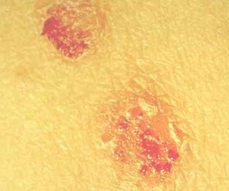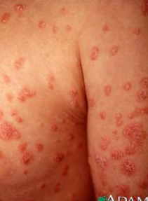
Erythrodermic psoriasis | Diffuse redness  Scaling  Possible fever and chills | 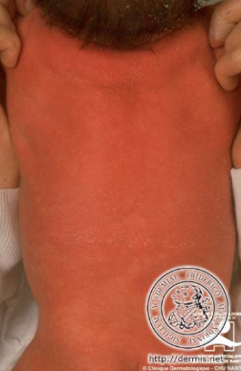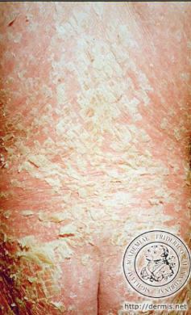
Pustular psoriasis | PMN accumulation  Sterile pustules  Triggers – pregnancy and withdrawal of systemic steroids | 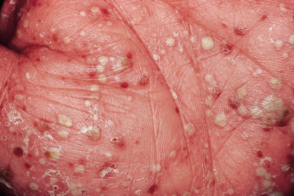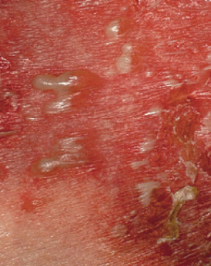
Chronic plaque-type psoriasis | Most common subtype  Polygenic predisposition  Skin findings – sharply demarcated, scaly, erythematous plaques, +/- white asbestos-like scale | 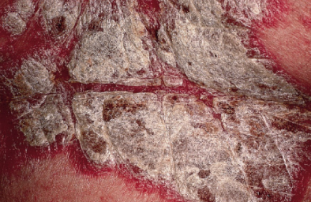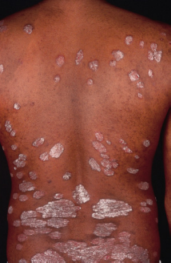
Auspitz’s sign – pinpoint bleeding when psoriatic scale is picked off
- Understand the concept of psoriatic arthritis
- Occurs in 5-30% of cases
- Typically the skin disease comes before the joint disease, but flares may coincide.
- 5 subtypes
  - Oligoarticular (less than 5 joints), asymmetric
  - Polyarticular, often symmetric
  - DIP predominant
  - Spondylitis spine predominant
  - Arthritis mutilans (highly destructive)
- RF negative, Uric acid may be high, CBC may show mild anemia.
- Joint and spine stiffness, sausage digits, synovitis
- Understand the mechanism of action of the biologic agents
- Topical treatment = mainstay
  - Emollients
  - Corticosteroids
  - Tars
  - Vitamin A/D derivatives
- Phototherapy
  - UVB – broad band or narrow band
  - PUVA
  - Laser
- Oral systemic therapy
  - MTX
  - Cyclosporine
- Injection systemic therapies
  - Adalimuumab
    - Anti-TNF monoclonal antibody
    - Human antibody, SQ injection, approved for RA and psoriaisis
  - Infliximab
    - Chimeric anti-TNF antibody
    - Infusion, approved for RA and psoriasis
  - Efalizumab
    - SQ weekly injection
    - FDA approved for plaque psoriasis
    - Mech – blocks T cell activation and diapedesis
  - Etanarecept
    - Anti-TNF agent
    - SQ injection 1-2 times weekly
    - FDA approved for: psoriasis, psoriatic arthritis, ankylosing spondylitis, RA
    - Acts like a sponge to sequester TNF
  - Alefacept – also anti-TNF
5. Know the triggers of psoriasis

External Triggers | ~Koebner or isomorphic response  ~Trauma elicits the eruption  ~Mechanical injury, sunburn  ~2-6 week lagtime
Systemic Triggers | ~Infections – Strep, HIV  ~Endocrine – hypocalcemia, pregnancy  ~Psychological stress  ~Drugs – Lithium, beta blockers, interferon  ~Withdrawal of systemic steroids

Lasers and Light in Dermatology
1. Understand basic biophysical properties of skin
- Light can be reflected, scattered, or absorbed by the skin
- Longer wavelength = penetrates the skin deeper
- Absorbtion is responsible for a transfer of energy from the photon to the skin cells, and is mediated by a chromophore.
- Both scattering and absorbtion determine the depth to which the light will penetrate the skin but only absorbtion will lead to a pathobiologic and phototherapeutic effect.
- Once absorbed, the energy will either generate heat or drive photochemical reactions.
  - Heat – lasers and intense pulsed lights
  - Drive reaction – UV light and photodynamic therapy
2. Explain how light can be used to selectively destroy components of the skin
- Lasers and Intense pulsed light
  - Selectivity has been increased by fine tuning the wavelength and pulse duration
  - Avoid unwanted epidermal thermal damage by cooling the skin surface during laser exposure. Also good for intraoperative pain relief
  - Intense pulsed light
    - Use multiple different wavelengths, so that multiple chromophores can be targeted with the same light exposure
    - Can be used to decrease effects of lentigenes, dyspigmentation, telangiectasias, fine wrinkles.
    - Risk of side effects secondary to non-specific dermal damage.
    - Includes IR which could cause deleterious side effects.
  - From laser resurfacing to non-ablative dermal remodeling
    - Use IR wavelengths to reach collagen and elastin levels. To prevent ablating and wounding the epidermis, the following measures are taken –
      - Use alternative IR wavelengths and concurrent skin cooling.
      - 1320 nm and 1450 nm seem to work well for this
  - Removing hair with light
    - Use of longer wavelengths and pulse durations minimizes side effects.
    - Side effects like paradoxical stimulation of hair growth have been reported.
3. Understand the therapeutic role of UV light on skin
- Immunomodulation
  - Best seen in psoriasis, where you get induction of T cell apoptosis
  - Use of UV light is limited by the need to avoid burning the unaffected skin.
    - With repetitive exposure, the skin will “photoadapt”, or require tolerance to UV light.
- Narrow Band UVB
  - Replacing PUVA, which accelerates aging and causes skin cancer.
  - As effective as PUVA without as many short term side effects.
  - Has been shown effective in psoriasis, vitiligo (but incomplete),
- Novel UV light sources
  - Unlike selective photothermolysis which is dependent on the rate and number of photons delivered to the skin, the effects of UV phototherapy are determined by the total number of photons that reach the skin.
  - Depending on light source, different exposure times are necessary.
  - UV lasers and IPLs claim psoriasis more effectively than conventional broad band UVB in the following ways –
    - Longer wavelength UVB
    - Can target only affected areas while sparing normal skin
    - Operate at higher irradiances so that shorter exposure times can be used
  - High intensity UVA can be used to treat pruritic disorders like atopic dermatitis and mastocytosis
    - Mech – UVA reduces cellular IgE binding sites and inducing apoptosis.
    - Also effective for sclerosing disorders but not widely used.
4. List indications of PDT for skin diseases.
- Administer a photosensitizer and then expose the skin to light. This allows the non-thermal destruction of neoplastic keratinocytes, sebaceous glands and hair follicles to be fine tuned (involves oxygen related photochemistry)
- Actinic keratosis – topical PDT using 20% ALA and a blue light. Painful and requires 2 days
  - Studies being done to shorten this and decrease associated pain.
  - Can also do 20% ALA, and activate with a red light.
- Photoaging – has been used, lacking long term followup info.
- Ablation of appendegeal structures – area of investigation.
- Truncal acne – possible use here.
  - Use has been increasing due to high reimbursement..compared to AK which is poorly reimbursed.
  - Both lasers and non-laser light sources have been used (red and blue wavelengths)

To sum things up a little more nicely….
Technique | Mechanism | Clinical uses
Laser | Heats chromophore  ~pulse duration dictates extent of collateral damage | Hair removal, nevus of Ota, port wine stain, tattoo,  *blood/hair – MS, low peak power  *tattoo/melanosomes – NS, high peak power
PDT | Produce toxic singlet oxygen, which accumulates in photosensitizer (use of incoherent light is ok) | Tumors – cause necrosis
UV phototherapy | Immunomodulation  ~Narrow band UV = new alternative to PUVA | Dermatitis, Vitiligo, Psoriasis

Disorders of Skin Color
1. Know the key determinants of skin color
- Components of skin that determine color:
  - Melanin – depends on amt. and location (epidermis = brown, dermal/epi jxn = black, dermis = blue)
  - Blood Vessels – vessel diameter and location of vessel clusters affects skin color
  - Thickness of stratum corneu and epidermis
2. State the various treatment options for vitiligo
- Psoralin either orally or topically plus PUVA – need many treatments, not ideal
- High potency topical steroids in limited disease
- Narrow band UVB is a more recent development – don’t need to take oral meds – still don’t get complete repigmentation
- Cosmetics
- If you get repigmentation, it starts as islands around hair follicles
3. Explain mechanism of laser therapy in the management of port wine stains
- Use pulsed dye therapy to lighten the lesions
- If they become thick or bleed, excisional surgery is an option.

Vitiligo –  depigmented white patches of skin via absent melanocytes; hairs in the area usually also white  most commonly on hands, elbows, knees, around eyes, mouth, rectum, genitals  possible autoimmune mechanism  peak incidence 10-30, familial cases common, progressive course  can be assoc. w/ thyroid dysfxn (Graves and thyroiditis), pernicious anemia, Addisons  tx. w/ makeup, psoralen + UVA, topical steroids; crappy prognosis for most, okay if young, had for <6 mo, and occuring on face | 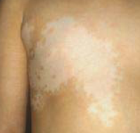
Lentigo-  brown macules and patches in sun-exposed areas  microscopically show elongated rete ridges, possible ↑ # melanocytes  occurs via UV photodamage to DNA in skin  very common, occur in 90% whites by age 70  tx. w/ liquid nitrogen, chemical peels, laser | 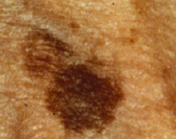
Port-Wine Stains –  congenital birthmark due to dilation of blood vessels  if following dermatomal distribution on face, beware Sturge-Weber syndrome = triad of glaucoma, seizures and a port-wine stain  tx. w/ laser light (green-yellow is best, as blue doesn’t penetrate deep enough) | 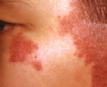

Dermatological Surgery
1. To gain an understanding of the scope of procedures performed by many dermatologists, dermatological surgeons, and Mohs surgeons
- Skin cancer treatment
  - Primary excision
  - Electrodessication and curettage
    - Simple, rapid, cost effective, for uncomplicated cases
    - Involves heating tissue and margin, then curreting…and repeat.
  - Mohs surgery
    - Mapping of tumor allows for smallest possible margin
  - Photodynamic therapy
    - Porphyrins are preferentially absorbed in damaged tissue, and free radicals selectively destroy the more active tissue.
    - Used for superficial carcinomas (Bowens, actinic keratosis, superficial basal cell carcinoma)
    - Cosmetically preferable for patients with many lesions
    - Area is left to incubate 1-2 hrs after porphyrin is applied.
    - Activate by various light sources
    - Skin will peel in 2-3 days, usually need 2-3 treatments total.
- Laser and Light therapy
- Botox injections – acts by cleaving vSNARES and tSNARES. Paralyze muscles
- Cutaneous resurfacing
  - Chemical peels (superficial, medium, deep)
  - Laser resurfacing
  - Dermabrasion
- Dermal filler injections
  - Silicone, collagen, autologous fat, hyaluronic acid
2. To develop an understanding of the diagnosis and treatment of common cutaneous malignancies, including pathogenesis and incidence
- Basal Cell Carcinoma
  - Most common cutaneous malignancy
  - Does not metastasize but can be locally destructive
  - Nodular most common type
  - Aggressive subtypes include micronodular, morpheaform, infiltrative and any with peri-neural invasion
  - Indications for Mohs surgery include:
    - Aggressive subtype, cosmetic location, high risk patient, young patient, tumor larger than 2 cm
- Squamus cell carcinoma
  - Second most common cutaneous malignancy
  - Actinic keratosis are precursor lesions
  - P53 mutations UV dependent
  - Can metastasize and rate depend on body site and patients immune status
    - Common sites – lymph nodes, lung, bone
  - Ear, lips, mucosal surfaces with much higher metastases rate
- Malignant melanoma
  - Most aggressive cutaneous malignancy
  - Prognosis based primarily on depth of lesion and any cutaneous ulceration
  - Early detection is key to increased survival

Photomedicine and Photodermatoses
1.Understand the cutaneous effects of different wavelengths of UV and visible light, including – penetration of UV and visible light to skin, UV-induced damage to DNA and repair of the damage, acute effects of UV (erythema, pigment darkening, delayed tanning, hyperplasia, vitD synthesis), chronic effects (photoaging, photocarcinogenesis)
- UVB and DNA damage – direct mechanism
  - Cyclobutane – pyrimidine dimer formation
  - Pyrimidine-pyrimidone 6-4 photoproducts
  - Most efficient at 300 nm
- UVA and DNA damage – indirect mechanism
  - Absorbed by skin chromophores – ROS – reacts with guanine – makes 7,8 dihydro-8-oxo-guanosine and 8-oxo-7,8-dihydro-2’-deoxyguanosine
- DNA damage repair
  - UVB damage is bulky due to 2 bases being linked….fixed by nucleotide excision repair pathway
    - Diseases of NER proteins – Xeroderma pigmentosum, Cockayne Syndrome, UV-sensitivity syndrome, Thrichothiodystrophy
  - UVA damage has extra oxygen on bases – non bulky – fixed by base excision repair pathway
- Photodermatology
  - Erythema – especially with UVB, usually delayed 2-6 hrs
    - SPF = ratio of minimal erythema dose of protected skin over MED of unprotected skin
  - Pigment darkening – occurs mainly as a result of UVA
    - Immediate – occurs in minutes, disappears in 10-20
    - Persistant – 2-24 hours
    - Occurs via oxidation of melanin, NOT formation of new melanin
  - Delayed tanning
    - Due to formation of epidermal melanin
      - UVB – preceded by erythema, fades rapidly
      - UVA – may blend with IPD and PPD, lasts longer
  - Hyperplasia - thickening of skin
  - Vitamin D synthesis – sunlight catalyzes converstion of 7-dehydrocholesterol to vit D3 in the skin
  - Chronic effects of UV
    - Photoaging
      - Activation of AP1 transcription factor – upregulation of MMPs, and less so TIMPs
      - Get degradation of dermal matrix followed by imperfect repair = solar scar = wrinkles
    - Photocarcinogenesis
      - SCC – chronic sun exposure
      - BCC – intermittent sun exposure
      - Melanoma – intermittent sun exposure??
2.Know about photoprotection – sunscreens
- Organic sunscreens – UVB filters and UVA filters
- Inorganic sunscreens – titanium dioxide and zinc oxide
- SPF = protected MED/unprotected MED. Need 2 mg/cm2 = 1 oz to cover entire body area
- Helioplex – Stabilizing complex which stabilizes UVB and UVA protection, used in many sunscreens
- Ecamsule – potent UVA blocker
3.Recognize selected photodermatoses including polymorphous light eruption, phototoxicity and photoallergy
- Polymorphous light eruption
  - Most common idiopathic photodermatosis
  - Most common in springtime in young adults
  - Gets better as the sun progresses
- Phototoxicity – common, reaction with 1st exposure, onset in min-days, clinically see blisters and hyperpigmentation, on histo, see necrotizing keratitis
- Photoallergy – low incidence, no rxn upon 1st exposure, onset 24-48 hrs later, clinically see erythema and edema, on histo see spongiotic dermatitis
Depths of penetration of light - UVB≤UVA≤visible light≤IR

Superficial Fungal Infections and Infestations of Skin
1.Introduce and discuss dermatophyte infections of skin, hair and nails
- Tinea = dermatophytic infection of the superficial skin
  - Tinea corporis = infections of trunk/proximal extremities
  - Tinea cruris = infection of groin area – thin pruritic erythematous plaques with well-defined scaly borders
    - Usually medial thighs, but spares penis and scrotum
  - Tinea pedis = feet, can be interdigitial, moccasin type, or vesicular type
  - Tinea capitis = scalp infection.
    - Pruritis, scaling, alopecia, papules, pustules
    - Fragile broken hairs results in a black dot pattern of alopecia
  - Tinea manuum = hands, dry and scaly, with pruritis
  - Tinea unguium (onchomycosis) = nail plate infection, often found with tinea pedis.
2.Elucidate the clinical manifestations, diagnosis and management of dermatophyte infections
- Diagnosis
  - KOH preparation of scale or hair
    - If positive, shows septate hyphae that branch at various angle and spores in hair shaft.
    - Confirms presence of infection but does not ID organism
  - Woods lamp – UV source to detect erythrasma caused by corynebacterium
    - Used to differentiate erythrasma from tinea cruris
- Treatment
  - Antifungal agents, topically or systemically
    - Topical – pedis, manuum, cruris, limited corporis – 1-2 times daily for several weeks
    - Systemic – capitis and unguium and widespread corporis
      - Griseofulvin = first line for t. capitis
        - Side effects: headache, nausea, rarely hepatotoxicity
      - Triazole agents for t. unguium – 2-3 months for fingernails, 3-4 for toes
        - Be cautious with other p450 metabolized drugs
        - Can rarely cause hepatotoxicity
      - Terbinafine – daily fashion (6 weeks fingers, 12 weeks toes)
        - Does not interfere with p450 drugs
        - Rarely, hepatotoxicity and leukopenia
  - Advise patients on avoiding humid conditions and wearing loose clothing and footwear, and avoiding contact with infected people
3.Discuss the clinical manifestation, diagnosis, and identification of common skin and hair infestations
- Superficial yeast infections
  - Tinea versicolor
    - Caused my malessezia yeast, very common
    - Most common in tropics and subtropics
- Scabies – caused by sarcoptes scabiei, which burry into stratum corneum to lay ova
  - Spread by close human contact, only visible on scraping from a lesion
  - Clinical – severe itching, with widely scattered macules, papules, pustules, burrows.
    - Crusted scabies in immunocompromised
  - Mites die after 48 hours of being removed from the skin.
  - Treatment – topical permethrin applied from neck down daily for a week.
    - Oral ivermectin for crusted scabies.
- Head and body lice
  - Severe itching to asymptomatic…very variable.
  - Treatment – topical, and clean all clothing .
- Crab lice
  - STD
  - Typical finding: maculae ceruleae, macules on lower leg due to bites of the louse.
  - Treatment – topical
4.Discuss the management of skin and hair infestation – see above

Eczematous Dermatitis
1. Understand the definitions of eczema and its key characteristics
- Dermatitis = eczema = non-infectious inflammation of the skin
2. Differentiate the various stages of eczema/dermatitis
- Acute – vesicles and blisters
- Subacute – plaques with indistinct borders, scale, fissuring
- Chronic – thickened skin
3. Differentiate the various representative types of eczema/dermatitis
- Atopic dermatitis
  - Chronic pruritic skin condition that usually has no primary lesion but manifests with lichenification, excoriations or erythema in flexural surfaces in adults. In children, it tends to be on face/extensor surfaces
  - Waning/waxing course
  - Very common, especially from infancy to adolescence.
  - History
    - Intractable pruritis with frequent secondary bacterial infections
    - Chronic dry skin is common
    - May be associated with allergic rhinitis and asthma = atopy
  - Physical exam
    - Lichenification, erythema, excoriations in skin folds in adult forms
    - In kids – erythematous, excoriated plaques on bilateral cheeks
  - Differential – contact dermatitis, nummular eczema, psoriasis, etc.
    - Diagnosis is a clinical one – rule out allergies/irritants, then go from diagnostic criteria
      - Major criteria – pruritis, morphology, disease course, family history
  - Histo – edema, thickening of epidermis, some lymphocytes in dermis
  - Pathogenesis – immunologic, along with possible barrier function
    - Seem to have genetic component
    - Upregulated langerhans cells → hyperactive immune response to normal irritants.
  - Therapy – Non alkali soaps, wet wraps, topical steroids if needed (ointment base for chronic, cream based for acute)
    - If low potency steroids fail – use immunomodulators like tacrolimus
    - If still fail, use high potency topical steroids, under careful supervision
    - Refractory cases – use phototherapy
- Contact dermatitis
  - Inflammatory process caused by external agent.
    - Irritant – occurs in most people after exposure to a particular amt of a substance
    - Allergic – occurs in subset after exposure to relatively small amt. of a substance
  - Very common, mostly in working adults
  - History – pruritis, occasionally painful fissures
  - Physical exam – Clinical finding are based on the stage of the disease (see#2)
  - Histo – may see swelling and thickening of epidermis and some lymphocytes, but diagnosis is clinical
  - Pathogenesis – Irritant dermatitis is caused by disruption of the epidermal barrier. In allergic dermatitis, patients have a type 4 hypersensitivity reaction
    - Causes of irritant dermatitis
      - Too frequent hand washing
      - Chemical agents like cement and cutting oils
      - Body secretions like feces in diaper dermatitis
    - Causes of allergic dermatitis
      - Rhus antigen (poison ivy, poison oak, etc)
      - Nickel
      - Compnents of rubber gloves
  - Therapy – avoid offending substance
    - Can do patch testing for allergic dermatitis
      - Emollients, topical steroids, or systemic if severe.
    - Phototherapy for refractory cases

Granulomatous Diseases
1. Understand the definition of granulomatous disease
- Disorders of macrophages and monocytes
- Dermal process, so usually presents as smooth papules or nodules
2. Understand the key clinical features, systemic manifestations and basic treatment of the representative disease for granulomatous, paunniculitis and vasculitic categories of disease
- Granuloma Annulare – idiopathic, self-limited reactive response within the skin. Benign condition
  - Common in adults and kids, higher incidence in women
  - Often found on dorsum of hands, feet, wrists, ankles. Typically asymptomatic, possible mild pruritis
  - Physical exam – skin-colored to erythematous papules with smooth raised borders, ranging from 1-5 cm in diameter. Can be isolated or coalesce into plaques. Most commonly in distal leg.
  - Histo – dermal granulomatous infiltrate palisading around a mucinous core.
  - Disease coarse –
    - Can be localized, generalized, perforating, subcutaneous, and actinic.
    - Localized disease is much more likely to resolve spontaneously than generalized.
    - Perforating - small papules, found mostly on hands and feet
    - Subcutaneous – more common in kids, get large skin colored nodules which may be very deep
  - Pathogenesis – unknown but seems to be reactive process of skin.
    - Stress? Diabetes? Diabetics seem to have multiple lesions/generalized disease
  - Therapy – None since often asymptomatic and self limiting.
    - Options – corticosteroids, electrodesicatoin, cryotherapy, UV light, systemic agents
- Sarcoidosis – systemic granulomatous disease involving many organs.
  - Not neoplastic, infectious, genetic, nutritional, autoimmune
  - Age of onset usually 20-40, seen worldwide
  - Cutaneous lesions are typically asymptomatic, but lung lesions cause SOB.
  - Physical exam - erythematous papules and nodules on face, eyelids, neck, shoulder which become more apparent upon stretching the skin.
    - Lupis pernio – lesions involve the nose/cheeks
    - Lofgrens syndrome – fever, hilar adenopathy, lesions of erythema nodosum
  - Histo – circumscribed granulomas with little or no necrosis
  - Therapy – Steroids, antimalarials and methotrexate have been used.
- Panniculitis
  - Inflammatoin localized to subcutaneous fat.
  - Deep, painful, erythematous, poorly demarcated plaques
  - Erythema nodosum
    - Rapid onset of erythematous, painful, poorly demarcated plaques, often pretibially.
    - Plaques flatten within a few days leaving purple to black patch
    - PE – Size of lesions vary from 1-15 cm, with 1-50 lesions present
    - Histo – inflammation of connective tissue between fat lobules
    - Path – reactive condition to infection, drug, malignancy, etc.
    - Therapy – determine underlyaing cause, NSAIDs, steroids, compression stockings
- Vasculitis – inflammation of blood vessels
  - Henoch-Schonlein Purpura
    - Inflammatory condition of venules, presenting with skin lesions, GI joint and renal involvement.
    - Peak age of onset 4-7 years
    - History – acute onset of purpuric rash, abdominal cramping and hematuria. However, there is a spectrum of disease, but cutaneous features are constant
    - PE – pink erythematous macules, urticarial plaques that develop into purpura (=non-blanching papules) in pressure and gravity dependent areas (knees, butt, etc)
    - Histo – neutrophilic inflammation around small blood vessels
    - Path – unknown but likely infectious etiology
    - Therapy – if renal involvement, need oral steroids. If only GI and skin, then topical steroids and NSAIDs

Acne Vulgaris and Rosacea
1. Understand the etiology and pathogenesis of Acne Vulgaris
- Various contributing factors, but pathophys is centered around pilosebaceous unit
  - Formation of microcomedone (corneocytes plug the follicular ostium)
  - Corneocytes continue to be shed, and sebum is made, leading to expansion rupture of the comedo wall.
  - Get extrusion of immunogenic keratin and sebum, resulting in inflammation.
    - Mostly neutrophils – pustule
    - T helper cells, lymphocytes, giant cells – inflamed papules, nodules and cysts
- Neonatal acne – caused by m. furfur.
- Acne – colonized by p. acnes, which are gram positive anaerobic rods. Get proinflammatory mediators, but the number of bacteria does not correspond with acne severity.
- Androgens increase sebum production, estrogens decrease sebum production.

2. Understand the different variants of acne
- Non-inflammatory
  - Whiteheads – closed comedones
  - Blackheads – open comedones
- Inflammatory – erythematous papules, pustules and nodules which may become indurated and tender.
  - Acne fulminans – most severe form of cystic acne
    - Men aged 13-16, get tender, nodular, suppurative acne
    - Face, neck, back and arms are affected.
    - See osteolytic lesions of bones due to systemic involvement. Also – fevers, myalgias
    - Treat with oral retinoids (can cause fulminans too), corticosteroids, antibiotics
  - Acne conglobata
    - Abrubt onset of nodulocystic acne with NO systemic manifestations
    - Acne conglobata = on trunk, dissection cellulitis = on scalp, hidradentitis suppurativa (axilla)
  - Acne mechanica – from friction
  - Acne excoriee – usually an anxiety issue, due to picking.
  - Drug-induced acne – monomorphous eruption of inflammatory papules
  - Occupatoinal acne – cutting oils, petroleum, CHCs, etc.
3. Determine the appropriate treatment for the different variants of acne
- Topical
  - Benzoyl peroxide – shows no bacterial resistance, basically cleans out skin
  - Salycilic acid
  - Antibiotics – Use with benzoyl peroxide to decrease resistance formation (clinda, erythromycin)
  - Retinoids – affect follicular keratinization
    - Side effects – irritation, erythema, dryness, scaling.
    - Tretinoin – inactivatedby sunlight, so use at night
    - Adapalene – less irritation, light stable
    - Tazarotene – very potent, but contraindicated in preg.
  - Azelaic acid – found naturally in cereal grains, lightens posinflammatory hyperpigmentation
  - Sodium sulfacetamide – topical antibiotic, but avoid in sulfa allergic patients.
- Oral meds
  - Antibiotics – tetracyclines (doxycycline, minocyline)
    - Can stain growing teeth, cause vertigo, and pseudotumor cerebri, blue-black pigmentation of scars
    - Phototoxicity with doxycyclines
  - Erythromycin – increasing resistance so not really used
  - Hormonal therapy – estrogen in females (BC), side effects – PE, HTN, thrombophlebitis
  - Spironolactone – blocks 5αreductase, has anti-androgen effects.
  - Isotretinoin – teratogenic, monitor triglycerides, can lead to pseudotumor cerebri
- Surgical
  - Comedone extraction, intralesional corticosteroid injections, chemical peels
4. Understand the differential diagnosis for rosacea
- Idiopathic chronic inflammatory disorder involving blood vessels and sebaceous glands.
- Differential – acne, lupus, polymorphous light eruption, seborrheic dermatitis, carcinoid syndrome.
  - No pustules in SLE, PLE, and SD
  - Comodomes and teenage years for acne
  - Carcinoid syndrome has episodic facial flushing
- Path – not well known, many triggers like sun, heat, caffeine, alcohol, spicy, stress
- Therapy – topical metronidazole, or systemic tetracycline, DON’T use topical steroids (they will aggravate)
- Coarse – can get rhinophyma = bulbous nose, can treat with laser.
Images
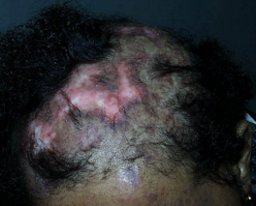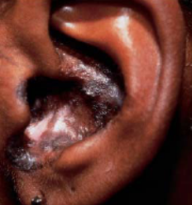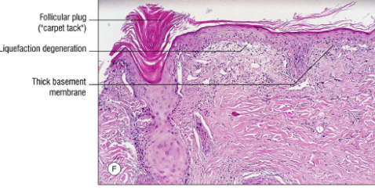
LUPUS – atrophic plaques with violaceous border and alopecia and scalp, similar lesions in the ear. Histo- note inflammation at the dermal-epidermal junction area

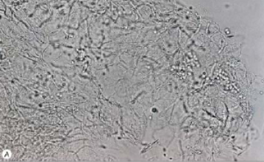
TINEA VERSICOLOR – KOH positive for fungus (m. furfur)

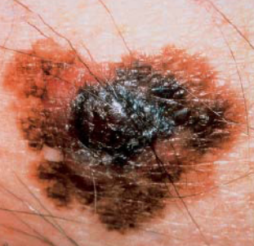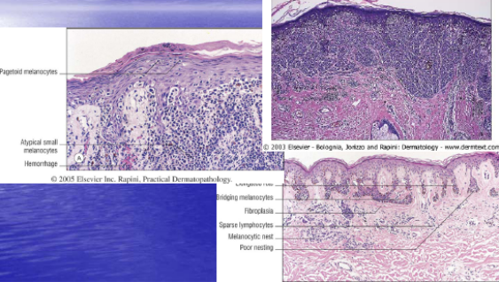
MELANOMA

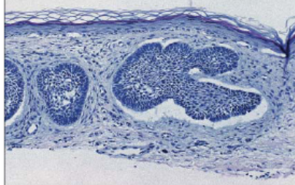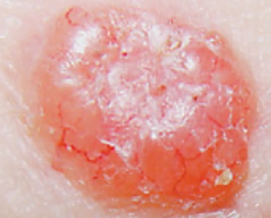
BASAL CELL CARCINOMA

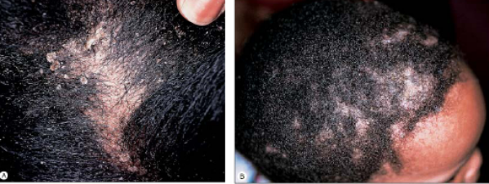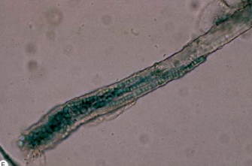
TINEA CAPITIS

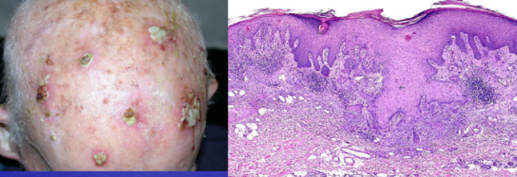
SQUAMUS CELL CARCINOMA

