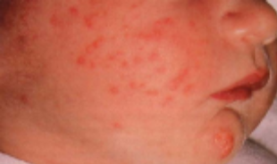
Neonatal Acne

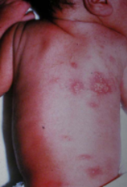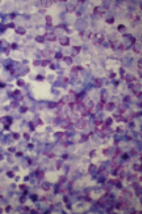
ETN

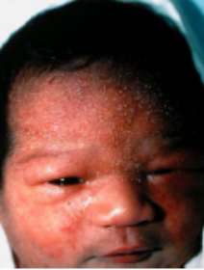
TNPM
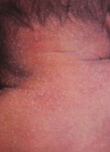
M. Rubra
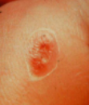
Sucking blister
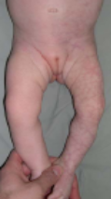
Cutis Marmorata

1. Nursery Findings
  - Neonatal “acne”
    - discrete papulopustules on cheeks, onset at 2-3 weeks, resolves by 3 months
    - Cause: Malassezia (yeast) or bacteria….not really known.
    - Treatment: ketaconazole, benzoyl peroxide, or do nothing
    - Mimicker: Sebaceous hyperplasia
      - Around alae, symmetrical, no erythema
  - Erythema Toxicum Neonatorum (ETN)
    - Common, in up to 50% of neonates
    - Sudden onset red blotchy patches, child otherwise well
    - Papules, pustules, vesicles, blotchy erythema on face, torso, limbs, buttocks…spares palms and soles
    - Microscopic- many eo’s
    - Treatment – none, will resolve on it’s own
  - Transient Neonatal Pustular Melanosis
    - 4-5% of black babies, .3% of Caucasians
    - Tiny pustules present at birth which rupture easily, leaving a dark spot
    - No erythema
    - Anywhere on the body, soles and palms included
    - Progression: vesico-pustules→collaret of scale→pigmented spots
    - Treatment: none, will resolve on it’s own.
  - Miliara Rubra (=prickly heat) and Crystallina
    - Superficial fragile vesicles, caused by obstructed sweat ducts
    - Affects forehead, neck, upper trunk
    - Often caused by mother who keeps child excessively warm – get obstruction of sweat ducts
    - Treatment: cooling
  - Sucking blisters
    - Caused by vigorous sucking, often on radial forearm, hands, wrist
    - Intact bullae, erosions
    - Treatment: stop sucking
  - Cutis Marmorata
    - Symmetrical mottling, present in almost all new borns when exposed to cold, most visible in legs
    - Asymptomatic, clears up by 6-12 months
- Congenital nevocellular birthmarks
  - Aplasia Cutis Congenita
    - Localized or widespread absence of skin, often seen on scalp
    - On scalp, can be seen in conjunction with a variety of other malformations
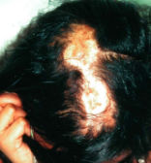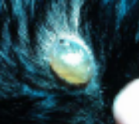
ACC – normal and bullous
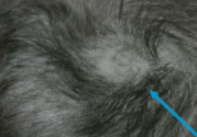
ACC - Hair collar sign

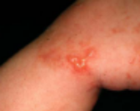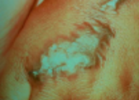
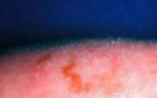
VP, verrucous, and hyperpigmented IP

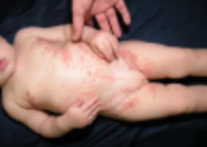
Viral reactivation of IP

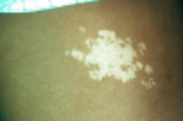
Nevus depigmentosus

Tuberous Sclerosis
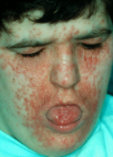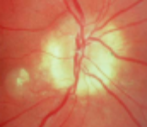
Angiofibromatous face,
Ophthalmologic abnormalities
    - Autosomal dominant transmission
    - Can be cause of elevated alpha fetoprotein levels
    - Hair collar sign
      - Looks like collar of hair around bald spot
      - Neural tube defects more likely in these kids
    - Bullous type
      - Very rare, but can connect to underlying brain spaces...so don’t stick
    - If associated with massive skull defect – think trisomy 13
  - Incontinenta Pigmenti
    - X linked dominant, male lethal
    - Phases – linear vesico-pustules, verrucous plaques, hyper and hyperpigmented streaks
    - Follow lines of Blaschko
Blaschko's lines, also called the Lines of Blaschko, are an extremely rare and unexplained phenomenon of human anatomy first presented in 1901 by German dermatologist Alfred Blaschko. Neither a specific disease nor a predictable symptom of a disease, Blaschko's lines are an invisible pattern built into human DNA. Many inherited and acquired diseases of the skin or mucosa manifest themselves according to these patterns, creating the visual appearance of stripes.
The cause of the stripes is thought to result from mosaicism; they do not correspond to nervous, muscular, or lymphatic systems. What makes them more remarkable is that they correspond quite closely from patient to patient, usually forming a "V" shape over the spine and "S" shapes over the chest, stomach, and sides.
It is theorized that the lines define the natural areas of growth between the original cells of the fetus and the later (copied) cells of mature adults.

    - Late atrophic stage can continue into adulthood
    - Long afterwards, viral infections can re-trigger inflammation along Blaschko lines
    - Associated with – abnormal teeth (65%), abnormal eyes (35%), Mental retardation (35%)
    - Cause: mutation in NFκB essential modulator (fail to activate NFκB which normally protects against TNF induced apoptosis
  - Nevus Depigmentosus
    - White spots, don’t change with age, epidermis is otherwise totally normal
    - Melanocytes present, just lazy
    - 5% of population has these
    - No big deal unless present with other symptoms like in…
  - Tuberous Sclerosis
    - White spots + mental retardation + seizures + angiofibromatous face
    - Signs: White spots, facial angiofibromas, shagreen spots (looks leathery on lower back), koenens tumors (on toes), astrocytic hamartomas on retina (DIAGNOSTIC – look like little salmon eggs around optic cup)

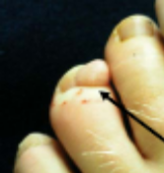
Koenens tumors

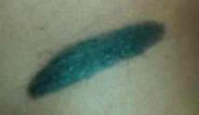
CNN

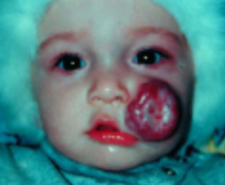
Hemangioma
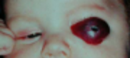
Ocular hemangioma
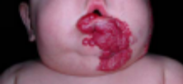
“beard” hemangioma

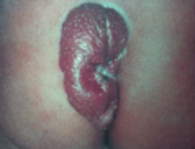
Gluteal cleft hemangioma

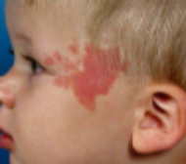
Port Wine Stain
Involved dermatomes of PWS | V2 only | V1 + V2 | V1+V2 bilateral | V2 + V3 | V1-3 | Neck or below
Probability of SWS | 2% | 4% | 22% | 0% | 20% | 0%
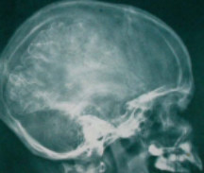
SWS calcifications
    - Tubers = abnormal (but benign) glial cell growths in brain, can cause ventricular obstruction – usually seen by grade school
    - Mutations have been ID’d on chromosomes 9 and 16
  - Congenital Nevocellular Nevi – dark spots
    - Can be smooth, bumpy, hairy, whatever
    - Melanoma risk – in large nevi, small but real risk (3-5%), in small nevi, not known but very small risk
    - If large, get an MRI to rule out neurocutaneous melanocytosis (= CNS melanocytic tumor = bad prognosis)
- Vascular Birthmarks
  - Hemangiomas – typically peak at 6 months, then gradually go away by 2-10 years
    - Why? – Thought to be caused by embolized placental cells (GLUT1 phenotype – normally only seen in blood barriers like CNS, placenta). More growth factors still present in premies, therefore hemangiomas are more common
    - Progression: Flat spot at birth, with rapid growth to 6 months, then regression
    - Treatment: Nothing, maybe compression or steroids
    - Surgical case = a hemangioma that is blocking the visual axis (the eye will be functionally blind if no visual input for first 4 weeks of life)
    - “Beard hemangioma” – wraps from ear to ear, may compress trachea and require tracheostomy.
    - PHACE syndrome – posterior fossa abnormalities, hemangiomas, arterial abnormalities, coarctation of aorta/cardiac defects, eye abnormalities
    - Gluteal Cleft Hemangiomas – May extend into spinal column and cause Cauda Equina symptoms
    - Kasabach Merritt Syndrome
      - Not associated with normal hemangiomas
        - Kaposiform hemangio-endothelioma
        - Tufted angioma
  - Nevus Flammeus = port wine stain
    - Present at birth, changes very little with age
    - Sturge Weber = PWS + glaucoma + abnormal CNS vascular involvement with calcification and seizures
      - Location matters!
    - Klippel Trenaunay Syndrome
      - Large vascular deformation with bony overgrowth
    - Nevus flammeus medialis = storks bite

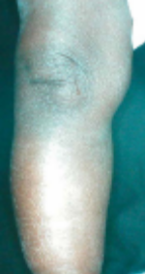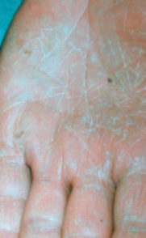
Ichthyosis Vulgaris

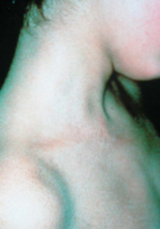
RXLI – “dirty neck”
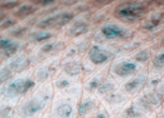
Scaly skin of RXLI

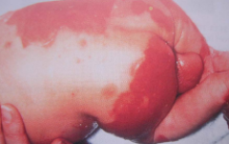
BCIE - baby
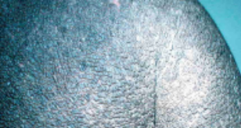
BCIE - child
      - Babies born with redness along facial midline
        - Common in newborns, fades with age
      - Posterior distribution – less likely to fade with age
- Ichthyosis
Keratin filaments – important intermediate filaments, major cytoskeletal proteins. There are 2 gene families (acidic and basic) which coexpress in pairs
Envelope precursors – Transglutaminase is very important for crosslinking.

  - Ichthyosis Vulgaris = common dry skin
    - Autosomal dominant, variable penetrance, often occurs with atopic eczema (gene linkage??)
    - Not present at birth – onset in dry conditions
    - Fine “ashy” scales especially on lower legs with sparing under socks (more humidity there)
    - Palmar hyperlinearity – rule out fungal causes
    - Commonly manifests itself in older people because of decreased lipid production
    - Treatments: Soak in warm water, use greasy moisturizer, use humidifier in home, keratolytics (salicylic acid) to shed scale, fruit acids to absorb water, urea, propylene glycol
  - Recessive X-linked Ichthyosis
    - Rare, females are not affected
    - Deficiency in Steroid Sulfatase, therefore elevated cholesterol sulfate but normal serum cholesterol
    - Subtle white scale, all over – spares wet areas (folds, diaper)
    - Small, tightly adherent scales behind and around ears, with relative sparing of central face (looks like “dirty neck”)
    - Often associated with asymptomatic corneal opacities
    - Generally associated with testicular non-descent (long term cancer risk)
    - Associated diseases: Kallman’s syndrome, Conradi-Hunerman syndrome
    - Perinatal complications – Placenta also has enzyme defect – therefore often associated with a prolonged labor
  - Bullous Congenital Ichthyosiform Erythroderma
    - Autosomal dominant, rare, aka epidermolyic hyperkeratosis
    - Generalized erythroedema at birth with skin fragility (flaccid blisters, peeling, superficial erosions = red scaly blistery baby
    - Hyperkeratosis with ridged, spiny, waxy scales in childhood
    - Children – occasional blisters, spiny, easily dislodged scales all over body, bad odor
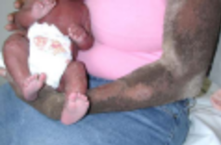
BCIE - adult
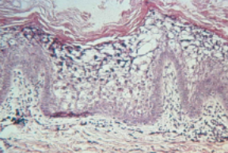
BCIE – pathology

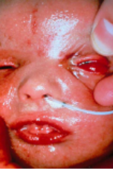
Collodion baby

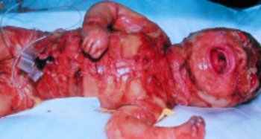
Harlequin baby

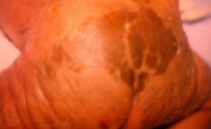
Lamellar Ichthyosis
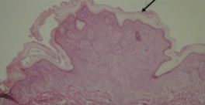
orthohyperkeratosis

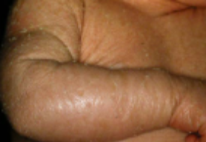
CIE

    - Adults – Some improvement, but odor remains a problem. Still have fragile skin and mild background erythema
    - Etiology: tonofilament aggregation error
      - Affects keratin 1 and /or 10
        - Note – 1 pairs with 9 in acral areas, so mutations in 10 don’t cause palmar plantar keratoderma
        - Mutations located at beginning of alpha helix rod domain
    - Treatment: oral retinoid therapy to shed scale
      - Works well, but monitor triglycerides and for diffuse interosseous skeletal hyperostosis
  - Collodion Baby
    - Shiny taught skin, everted eyes, puckered mouth, flexed fingers
    - Possible outcomes – congenital ichthyosiform erythroderma, lamellar ichthyosis, normal, psoriasis, etc.
  - Harlequin fetus
    - Very rare, autosomal recessive
    - Very severe form of ichthyosis, with thick inelastic skin
    - Used to die within a few days, but now living because of retinoids – still have extremely severe congenital ichthyosiform erythroderma
  - Lamellar Ichthyosis
    - Autosomal recessive, defect in transglutaminase (can’t cross link in granular layer)
    - Pathology – massive compact orthohyperkeratosis, with an otherwise normal epidermis
    - Clinical – born colloidal membrane, scaling in first month with little redness underneath, does not affect nails mouth teeth but doesn’t spare face or folds
    - Fissures can be painful
    - Can have joint contractures or digital sclerodatyly
    - Sweat ducts may be blocked – need to prevent hyperthermia
    - Treat with: emollients, keratolytics, retinoids, anti-pruritics, treat contracture
  - Congenital Ichthyosiform Erythroderma
    - Autosomal recessive, caused by defect in transglutaminas
    - Generalized erythroderma and fine scaling of the entire skin surface, usually present at birth. The erythema tends to decrease in later life and may disappear in middle age, but the scaling persists and may even worsen with age.
    - NOT bullous

