NEUROPATHOLOGY
- Normal cell types in CNS/PNS
  - CNS (origin neuroectoderm)
    - Neurons: generated before birth, post-mitotic, use ox metab, high degree of specialization
    - Astrocytes: provide structure, react to injury, forms BBB, synthesizes GFAP
    - Oligodendrocytes: myelinate many axons
    - Ependymal cells: line ventricles, secrete CSF
    - Choroid plexus: synthesizes CSF
    - Microglia: immune cells
  - PNS (origin neural crest)
    - Schwann cells: myelinate one axon, ability to regenerate myelin
- Meninges
  - Pachymeninges (dura)
    - Forms potential spaces: epidural and subdural
    - Forms dural folds: tentorium (btw cerebrum/cerebellum) and falx (btw cerebral hemispheres)
  - Leptomeninges (arachnoid/pia)
    - Forms potential spaces: subarachnoid (w/ CSF) and intraparenchymal
- CSF production and circulation
  - Produced by ependymal cells of choroid plexus from blood plasma (0.5L/d independent of ventricular pressure)
  - Lateral V → 3rd V via foramen of Monro → 4th V via cerebral aqueduct → subarachnoid via foramen of Magendie (med)/Lushka (lat)
  - Reabsorbed by arachnoid granulations to venous system of brain
  - Normally little protein, few leukocytes
- Hydrocephalus (enlargement of ventricles)
  - Obstructive: blockage of CSF flow w/in the ventricle,  ICP
  - Non-Obstructive (communicating): blockage outside the ventricle,  ICP
  - Ex Vacuo: compensation for brain atrophy, especially in elderly (think Alzheimers), normal ICP
  - Normal Pressure Hydrocephalus: rare syndrome w/ normal ICP but dementia, urinary incontinence, disordered gait
- Blood-brain barrier (tight junctions btw capillary endothelium and perivascular astrocytes)
  - Many drugs cannot pass intact BBB (good and bad)
  - Breakdown (seen as enhancement) due to inflammation → vasogenic edema, kernicterus
- Brain edema
  - Vasogenic: damage to BBB (inflammation, infarct, tumor) causes leakage, mainly in white matter
  - Cytotoxic: ion pump dysfunction (hypoxia, toxins) causes cell swelling, in both gray/white matter
  - Interstitial:  intraventricular pressure (hydrocephalus) pushes fluid out into periventricular white matter
- Increased ICP
  - B/c of rigid skull, anything that increases volume (tumor, abscess, edema, hemorr) can increase ICP
  - Sx: headache, projectile vomiting, papillodema, decline in LOC, cardiorespiratory changes (brady, HTN, irreg resp), focal signs
- Herniation: brain structures are pushed through anatomic openings due to increased ICP
  - Cingulate: cingulate gyrus under falx cerebri → ACA compression → foot/leg homunculus loss
  - Uncal: UNILAT uncus under tentorial incisure → midbrain/CNIII compression → coma, aniscoria, duret hemorr
  - Central: BILAT dienceph/med temporal under tentorial incisure → midbrain/thal compression → coma, hydroceph, posturing
  - Tonsillar: cerebellar tonsils/medulla thru foramen magnum → medulla compression → loss of consciousness, apnea
- Define
  - Astrocytosis: acute hyperplasia/hypertrophy
  - Gliosis: chronic proliferation of processes → glial scar, common in multiple sclerosis (think x-sxn of SC w/ dark staining)
  - Selective vulnerability: certain neurons are susceptible to certain dz (ex) B12 defcy → Wernicke’s encephalopathy
  - Wallerian degeneration: degredation of axon distal to site of lesion
    - Can be anterograde (loss of neuron → loss of target cell) or retrograde (loss of target cell → loss of neuron)
  - Demyelination:
    - 1° is a disease that destroys myelin but spares axon (ex) MS or Guillain-Barre
    - 2° is breakdown of myelin following axon degeneration (ex) Wallerian degeneration)
  - Dysmyelination: abnormal myelin (ex) leukodystrophies
  - Mass lesion: any pathologic process producing an increased volume, thus increased ICP
  - Respirator brain: ICP > arterial P → ischemia/brain death → diffuse brain autolysis IF pt is kept alive by respirator

NEUROANATOMY
- Important areas: primary motor, Brocas (frontal), primary sensory (parietal), auditory, Wernickes (temporal), visual (occipital)
- Upper motor neurons
  - Lesions → spastic paralysis (greater weakness in extensors), hyperreflexia, +Babinski
  - Contralateral if above decussation, ipsilateral if below
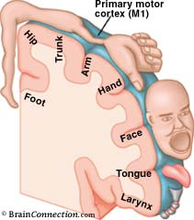
- Lower motor neurons
  - Lesions → flaccid paralysis, hyporeflexia, muscle atrophy, fasiculations (indicates denervation)
  - Always ipsilateral
- Cerebellum
  - Lesions → ataxia, dysmetria, intention tremor
- Basal ganglia (caudate, globus pallidus, putamen, substantia nigra)
  - Lesions → dyskinesias, rigidity, resting tremor
- Brainstem
  - Decerebrate posturing = upper/lower extremity extension
  - Decorticate posturing = upper flexion, lower extension
- Spinal cord
  - Acute transection → complete paralysis/anesthesia/areflexia below lesion
  - Chronic transection → complete paralysis/anesthesia but hyperreflexia below lesion
  - Central cord syndrome
    - Bilateral loss of pain/temp (spinothalamic) at level of lesion, since decussates at level it enters SC
    - UMN loss of upper > lower (corticospinal)
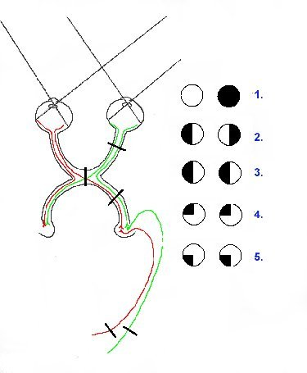
  - Anterior cord syndrome
    - Bilateral loss of pain/temp below lesion (already decussated)
    - Bilateral UMN loss below lesion
  - Brown-Sequard syndrome (hemisxn)
    - Contralateral loss of pain/temp below lesion
    - Ipsilateral UMN/LMN/proprioceptive loss below lesion
- Visual pathways
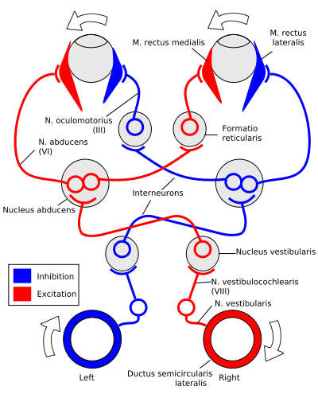
  - R optic nerve lesion → total blindness in R eye
  - Optic chiasm lesion → bitemporal hemianopia
  - R optic tract lesion → L homonymous hemianopia
  - R Meyers loop lesion → L homonymous superior quadranopia
  - R occipital lobe lesion → L homonymous hemianopia w/ macular sparing
  - Pupillary light reflex aff = CNII, eff = CNIII (constriction is para)
- Extraocular movements
  - CNIII: sup rectus, inf rectus, med rectus, inf oblique
    - Ptosis due to CNIII lesion (levator palpebrae loss)
    - Internuclear opthalmoplegia due to MLF lesion (no adduction w/ lat gaze)
  - CNIV: sup oblique (intorsion/depression)
  - CNVI: lat rectus
- Vestibular pathways
  - Look R = activate R/inhibit L CNVIII → L abducens + R medial rectus → fixed gaze
- Example syndromes from lecture
  - Wallenbergs syndrome (medullary lesion)
    - Ipsi: ataxia (cerebellum), loss of face pain/temp (CNV), palate paralysis (CNX), Horners (CNIII), nystagmus (CNVIII)
    - Contra: loss of body pain/temp (spinothalamic)
  - Saturday Night palsy (radial n lesion)
    - LMN symptoms w/ wrist drop, see in epileptics who seize and pass out w/ arm over chair, thus compressing nerve
  - Posterior occipital lobe infarct (PCA lesion)
    - Affects visual cortex → contralateral homonymous hemianopia
  - Motor stroke (internal capsule lesion)
    - NO sensory fibers are affected and it is purely an UMN syndrome
  - MCA lesion
    - Contralateral motor/sensory loss, homonymous hemianopia, language deficits

NEURODEVELOPMENT
- Any disturbance in acquisition of motor/cognitive/language/social skills can cause developmental delay in a child (MR=mental retardation)
- PREnatal errors
  - Malformations
    - Dorsal induction (3-4w) → neural tube defect
      - Failure of neural tube closure
        - anencephaly: NO ant neuropore closure → degen of brain
        - myelomeningocele: NO post neuropore closure → SC/meninges thru vertebral defect
      - Failure of mesodermal devel’p (neural tube is closed)
        - encephalocele: brain/meninges thru skull defect, usually occipital, assoc w/ Meckel-Gruber
        - meningocele: meninges thru skull or verterbral defect, assoc w/ Arnold-Chiari
        - spina bifida: mild lumbar vertebral defect but intact skin
    - Ventral induction (5-6w) → holoprosencephaly (failure of devel’p of cerebral hemispheres), often w/ no corpus callosum
      - Assoc w/ mid-facial deformities – cyclopia, cleft lip/palate, no nose
      - Causes: trisomy 13/18, maternal DM, infxn, EtOH
    - Neuron proliferation (2-4m) → microcephaly (genetic/teratogens/infxn) or macrocephaly (failure of apoptosis)
      - Neurons normally arise from germinal cell matrix
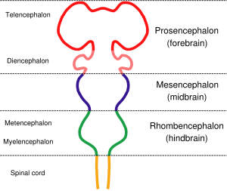
    - Neuron migration (3-5m) → agyria (migrational arrest in white matter → lissencephaly)
      - Neurons travel inside-out along radial glia
      - Manifests as devlp delay (NOT progressive, just never there in the first place)
      - Due to presence of hydrocephalus during migration
    - Synaptogenesis/myelination (6m-postnatal) → trisomy 21, leukodystrophies
      - CN normally myelinated by birth, progresses from posterior to anterior (sight then speech)
      - Dysmyelination is abnormal myelin compound
        - Pelizaeus-Mersbacher Disease: nystagmus, spasticity
        - MLD: confluent white matter, vision problems, spasticity
        - Aquaduct stenosis: huge 3rd ventricle, sunsetting
  - Maternal conditions
    - Fetal Alcohol Syndrome: most common preventable form of MR
      - Assoc w/ growth defcy, microcephaly, MR, facies (flat face, thin upper lip, short palpebral fissures)
    - Toxins: cocaine, anticonvulsants, lead, radiation
    - Infxns: TORCH organisms (Toxoplasm, Other, Rubella, CMV, Herpes)
  - Genetic dz
    - Trisomy 21: autosomal recessive, risk increases w/ maternal age
      - Assoc w/ MR, hypotonia, microcephaly, facies/simian creases, congenital heart defects
    - Fragile X syndrome: CGG repeats, males
      - Assoc w/ MR, macrocephaly, long face/big ears. macro-orchidism
    - Prader-Willi: 15q12 mutation (missing paternal), males
      - Assoc w/ hypotonic baby, short stature, hypogonadism, voracious appetite
    - Angelman: 15q12 mutation (missing maternal), females
      - Assoc w/ MR, inappropriate laughter/smiling, seizures
    - Rett syndrome: MEPC2 mutation, females
      - Assoc w/ MR, hand wringing, regressive
    - Neurocutaneous dz
      - Tuberous Sclerosis: autosomal dominant, TSC mutation (chr 9/16)
        - Assoc w/ MR, seizures, variety of tumors, shagreen (velvety) patches
      - Neurofibromatosis I: autosomal dominant, NFI mutation (chr 17/22)
        - Assoc w/ café au lait spots, neurofibromas, axillary freckles, optic gliomas, Lisch nodules
      - Sturge Weber syndrome: actually not genetic (sporadic)
        - Assoc w/ MR, facial angiomas, seizures, hemiparesis
- PERInatal errors
  - Hypoxic-ischemic encephalopathy: necrosis of vulnerable gray/white matter → permanent focal deficits
    - Significant cause (but one of many) of cerebral palsy
  - Cerebral palsy: static dz w/ varying degrees of MR, language/social deficits, and motor dysfxn
    - Assoc w/ germinal matrix bleeds, periventricular leukomalacia (holes in white matter), thin CC
    - Spastic (hemi/quad/diplegic) or extrapyramidal (non-spastic, choreic) types
    - RF = young mother, male baby, premature, infxns, 3rd trimester bleeds
- POSTnatal errors (not evident until after birth)
  - Inborn errors of metabolism: manifests as irritability, abnormal muscle tone, seizures, unusual odors, vomiting/refusal to eat
    - Acidopathies: (ex) Maple Syrup Urine dz, buildup of branched chain amino acids
    - Lysosomal storage dz: (ex) Hurlers/Hunters, buildup of MPS
    - Glycogen storage dz: (ex) Pompe’s Disease, lack of acid maltase → cardiac probs and death w/o tx
- Patterns of Brain Injury
  - Premature Infants
    - Periventricular necrosis: ischemia → focal necrosis in deep cerebral white matter (not watershed like adults)
    - Germinal matrix bleed: even small bleeds → cognitive dysfxn, increased risk of cerebral palsy
  - Perinatal
    - NOT usually periventricular
    - Hypoxic/ischemic encephalopathy (difficult labor/delivery, respiratory distress syndrome)
    - TORCH infxns can be transmitted during birth (ex) periventricular Ca + hydrocephalus w/ CMV
  - Postnatal
    - Child abuse/neglect (subdural bleed as a sign of trauma, think shaken baby syndrome)
- Assesing development: hx (maternal, delivery, milestones), PE (wt/ht/head circum/skin/fontanelles), non-invasive neuro, labs

AGE | DEGREE OF DEVELOPMENT
Neonate | Fetal position/head lag/reflex grasp, responds to light, cries
2 mo | No head lag/reflex grasp, follows with eyes, vocalizes, smiles
6 mo | Sits unsupported/reaches for & grasps objects, responds to sounds, babbles, stranger anxiety
10 mo | Crawls/pincer grasp, mama/dada, peekaboo
1 yr | Stands/walks, single words, tries to feed self
2 yr | Steps/hand dominance, short sentences, organized play, toilet trained

REFLEX | ONSET | DISAPPEARANCE
Rooting (baby turns mouth toward mothers nipple) | Birth | 3 mo
Moro (if startled, aBduct then adduct arms) | Birth | 6 mo
Palmar Grasp (baby grips things put in hand) | Birth | 6 mo
Tonic Neck (arm stretches ahead of gaze) | Birth | 6 mo
Plantar Grasp (same as Babinski) | Birth | 9 mo
Landau (flex hips and neck extends) | 3 mo | 2 yr
Parachute (put out arms to brace fall) | 6 mo | persists

NEURORADIOLOGY
- Primarily use CT/MRI
  - CT: Xrays show differences in tissue densities
    - HI density (white) = bone, calcification, blood, tumor
    - LO density (dark) = CSF, edema, fat
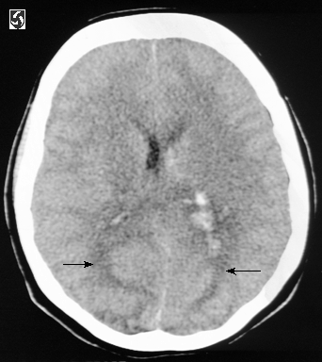
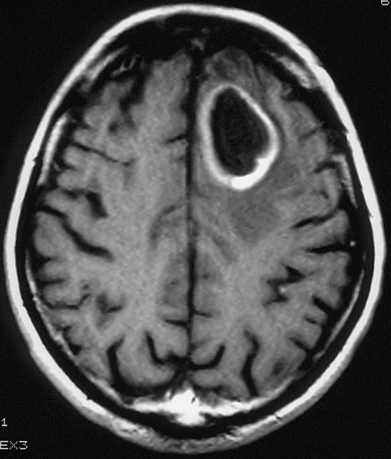
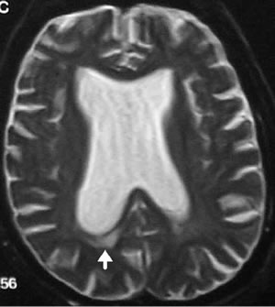
  - MRI: magnetic fields show difference in signal intensity
    - T1 = CSF/edema dark, WM light/GM dark
    - T2 = CSF/edema bright, WM dark/GM light
    - FLAIR has dark CSF but WM dark/GM light
    - DWI used for acute stroke
  - Contrast enhancement if a leaky BBB
    - Diff dx for ring enhancing mass
      - Metastasis
      - Glioma (HI grade)
      - MS plaque
      - Abscess
      - Lymphoma/Toxoplasmosis in AIDS
Non contrast CT w/
vasogenic edema
T1 MRI w/ ring enhancing lesion
T2 MRI w/ hydrocephalus
      - Resorbing hematoma
      - Radiation necrosis
- Edema
  - Vasogenic: follows white matter tracts in “finger-like pattern,” assoc w/ BBB breakdown (infxn, mets)
  - Cytotoxic: intracellular edema that involves both gray & white matter, assoc with strokes
  - Interstitial: CSF escape from ventricles into periventricular areas, assoc w/ hydrocephalus

- Tumors
  - Astrocytoma (cerebral hemisphere)
    - Features (HI grade): thick, irregular rim around necrotic core, enhance intensely, vasogenic edema
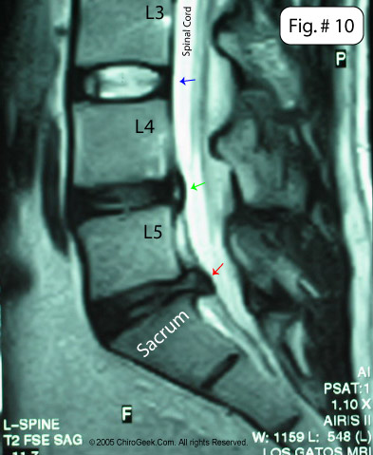
    - Features (LO grade): focal, homogenous, NO enhance
  - Oligodendriglioma (superficial cerebral hemisphere)
  - Ependyoma (4th ventricle)
    - Features: in region of cerebellum, assoc obstructive hydrocephalus
    - Choroid plexus tumor (children = lateral ventricle ; adults = 4th ventricle)
  - Meningioma (extra-axial)
    - Features: well circumscribed, enhance homogenously/intensely, CT best
  - Metastasis (anywhere, look for multiple!)
    - Features: enhance homogenously/ring, vasogenic edema
- Infections
  - Encephalitis: affects temporal lobes, think HSV
  - Meningitis: enhancing sulci due to pus accumulating
  - Cerebritis: often at corticomedullary junction, ring enhancing w/ lots of edema
  - HIV associated
    - HIV encephalopathy: atrophy
    - Toxoplasmosis: ring enhancing “target” appearance
    - Lymphoma: ring enhancing, cannot distinguish this from toxo w/ imaging
    - PML: very bright w/ T2 due to demyelination
    - Crypto: cystic appearing lesion in deep cortex
Blue: normal
Green: bulge
Red: herniation
- Multiple sclerosis: asymmetrical periventricular plaques (active will enhance, thus ring enhancing), MRI more sensitive
- Spinal cord
  - Degenerative dz: disc bulge, disc herniation (will see cord compression), spondylosis (spurs)
  - Trauma: use CT for fracture (e.g. compressed vertebrae), MRI for complications (e.g. edema, blood)
  - Syrinx: pathological cavity in SC, looks like segmented dark areas on T1/light areas on T2
  - Infxn: osteomyelitis (heterogenous look to bone/disk narrowing), sarcoid/TB lesions (multiple plaques)
  - Tumors
    - Extradural: most likely a met, +enhancement
    - Intradural/extramedullary: inside dura but outside SC, +enhancement
    - Intradural/intramedullary: inside SC, +enhancement, SC enlargement

NCS/EMG
- Nerve conduction studies
  - Distal latency: delay btw nerve stimulation and muscle contraction (= time as AP crosses NMJ)
    - Prolonged latency indicates demylination
  - Conduction velocity: = segment distance/segment latency
    - Slowed velocity indicates demylination
  - Amplitude: reflects # motor units recruited
    - Decreased amplitude indicates axonal loss
  - Repetitive stimulation: assesses amplitude over time
    - Abnormal decrement dx of myasthenia gravis
  - H-reflex: assesses proximal n (dorsal root/ant horn)
    - Decreased reflex + rest of motor responses are normal indicates proximal slowing
  - F-wave: assesses proximal n (ant horn only) via retrograde conduction
    - Prolonged latency/absent F-wave indicates proximal slowing, seen w/ radiculopathies, spinal processes, Guillen Barre
- Electromyography (used to distinguish btw neuropathies/myopathies)
  - Fibrillation: pathological, indicates denervation in either case
  - Amplitude:
    - Neuropathy = large, indicates prior denervation + re-innervation
      - Re-innervation - surviving motor units pick up denervated fibers & these extra muscle cells → bigger amplitude
    - Myopathy = small, indicates less recruitment due to loss of muscle cells
  - Recruitment: first increase frequency, then increase #
    - Neuropathy = normal amplitude but less interference vs myopathy = decreased amplitude but full interference
  - SF jitter: assesses temporal variability of 2 muscle fibers of the same motor unit
    - Not specific for myasthenia gravis but very sensitive

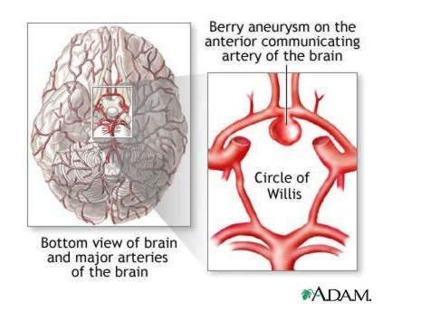
PATHOLOGY OF STROKE
- Cerebral vasculature
  - Internal carotid a → ACA/MCA
    - ACA: medial cerebrum
    - MCA: lateral cerebrum, basal ganglia, Brocas/Wernickes
  - Vertebral a → basilar/PCA
    - PCA: inferior temporal lobes
  - Penetrate as perforators = end arteries, thus watershed areas (ischemic penumbra)
  - Poor collateral circulation
  - Causes of CVD: atherosclerosis, aneurysms, amyloid angiopathy, vasculitis, malformations, thrombo-emboli
- Stroke
  - Acute neurological dysfunction due to a vascular process that persists >24h
  - Many pts die a few days later due to inflammation → increased ICP → herniation
  - Ischemic stroke (infarct)
    - Ischemia → rapid onset of neurologic deficit
      - Focal deficits due to reduced flow in one vessel
      - Global deficits due to systemic failure (hypoxia, hypoglycemia, hypoTN)
    - Central infarcted dead tissue with potentially viable “stunned” penumbra
    - Damage from hypoxia + glutamate excitotoxicity, Ca/Na influx, inflammation, apopotosis
    - Affects neurons>oligodendrocytes>astrocytes
    - Irreversible damage occurs after ~5m
    - Reperfusion may → more neuronal injury (from ROS damage) or hemorrhagic infarct
    - Causes
      - Idiopathic
      - AS of large vessels → stenosis, sudden occlusion, distal embolization
      - AS of small vessels → lacunar infarcts, normally seen w/ chronic HTN
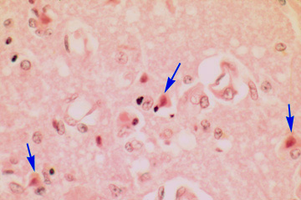
      - Elderly/A-fib → cardiac emboli which go to brain
    - Pathology
      - 12-24h: red neurons (necrosis) + acute inflamm (→ vasogenic edema)
      - 1-5d: liquefaction (encephalomalacia) + MΦ
      - 1w: astrocyte proliferation
      - 1mo: gliosis + cavitation
      - Late Δs: wallerian degen, atrophy, compensatory hydrocephalus
  - Hemorrhagic stroke (non-traumatic)
    - Spontaneous rupture of blood vessel → subarachnoid or intraparenchymal bleeds
      - Intra-axial (aka intraparenchymal)
        - Ganglionic: basal ganglia bleed, due to HTN vascular dz, assoc w/ Charcot-Bouchard aneurysms
        - Lobar: superficial lobe bleed, due to small vessel dz
      - Extra-axial
        - Epidural: more likely due to trauma, esp MMA, “silent” interval of 6-12h
        - Subdural: more likely due to trauma, esp dural sinuses
        - Subarachnoid: base of brain, due to rupture Berry aneurysm, arterial vasospasm, thunderclap HA
    - Causes
      - Hypertensive vascular disease (most common) → Berry aneurysm (which can also be congenital!)
      - Amyloid angiopathy (think elderly w/ Alz) → weakening of vessel walls that predisposes to hemorrhage
    - Pathology
      - Acute hemorrhage will show a mass of blood → mass effect
      - Resorbed hematoma → cavitation
- Diffuse hypoxic/ischemic encephalopathy
  - Global cerebral ischemia due to profound systemic hypoTN (ex) cardiac arrest
  - Damage is usually symmetrical and affects vulnerable cell populations
    - Sommer’s Sector (CA1) of hippocampus
    - Middle cortex (see laminar necrosis)
    - Watershed zones
    - Purkinje cells of cerebellum
  - Severe irreversible damage → persistent vegetative state, brain death, or respirator brain (autolysis)

CLINICAL STROKE
- Types of stroke
  - Ischemic, due to vessel obstruction
  - Hemorrhagic stroke, due to vessel rupture
  - Transient ischemic attack
    - Focal neurologic deficit with complete resolution of all neuro sx w/in 24 hours
    - Common in elderly
    - Often results in stroke in w/in next few days
- Risk factors
  - Non-modifiable: age, gender, previous stroke, family hx of stroke, sickle cell dz
  - Modifiable: HTN (BP directly related to risk), DM, high LDL, smoking, obesity, sedentary lifestyle
- Sx
  - Sudden onset (w/in 10 seconds)
  - Weakness/numbness/incoordination on one side of body
  - Sudden headache/confusion/change in speech/diploplia/vision loss
- Evaluation
  - Focused neuro exam: LOC, language, eye mvmts, strength, coordination, sensation
  - Presence of carotid bruits
  - CT head w/o constrast to differentiate hemorrhage vs ischemic stroke (which H&P cannot)
- Tx (acute stroke)
  - Door to tx in 1h
  - ONLY give t-PA if <3h since pt was last seen normal (otherwise ASA)
    - must be >18, CT shows ischemic stroke, exam shows measurable deficit
    - NEVER use in hemorrhagic stroke as would only exacerbate the bleeding
  - Lower BP if >220/110, even then must slowly lower
  - Complications: seizures, MI, aspiration pneumonia (impaired swallowing), DVT/PE (bedrest), depression/confusion
- Long term management
  - DOC is ASA, easy/safe/cheap/effective
  - Warfarin w/ high risk A-fib pts
    - HI risk: previous stroke/TIA, +CHF, +HTN, older than 75
    - LO risk: no previous stroke, no HTN, younger than 65 – JUST ASA!
    - MED risk: no previous stroke, +HTN, 65-75 – clinical decision
  - Statins to lower LDL cholesterol
  - Diuretics/ACEI to lower BP
  - Lifestyle modifications
  - Surgery
    - Carotid endarterotomy: removes plaques from vessels
    - Carotid stenting: increasingly used, but only FDA approved for HI risk pts w/ sx stenosis
  - Primary prevention (asx) = antiplts + RF management + CEA if stenosis 80-99%
  - Secondary prevention (sx) = antiplts + RF management + CEA if stenosis 50-99%

PATHOLOGY OF BRAIN TUMORS
- Can’t classify as benign/malignant (as a benign tumor in an important spot = really bad), thus Px based on location/resectability
  - DO assign as HI grade 3-4 (rapid growth, poor px) or LO grade 1-2 (easily resectable, slow-growing, good px)
- Sx are due to mass effect (increase ICP → HA, papilloedema, projectile vomiting, herniation) or local damage (focal deficits, seizures)
- Age/etiology
  - Children
    - Posterior fossa (cerebellum/brainstem)
    - Mainly 4th ventricle ependyomas, cerebellar astrocytoma/medulloblastoma
  - Adults
    - Cerebral hemispheres
    - Mainly cerebral astrocytoma/glioblastoma, metastasis, meningioma
- Primary: tumors whose cell type is a normal component of the nervous system
  - Neuroectodermal origin
    - Gliomas (differentiated)
      - Diffuse astrocytoma: infiltrative, aggressive (grade 2-4), enhancing (vessel prolif + necrosis destroys BBB)
        - Grade 4 form is glioblastoma w/ pseudopalisading (rim of nuclei around necrosis)
      - Pilocytic astrocytoma: children, grade 1, solid/cystic, Rosenthal fibers (prot in astrocyte processes)
      - Oligodendroglioma: 30yo, infiltrative w/ fried-egg cells + calcifications, → seizures
      - Ependymoma: solid tumors that grow into ventricles → obstructive hydroceph/mass effect
      - Choroid plexus tumor: occurs w/in ventricles → obstructive hydroceph/mass effect + overproduction of CSF
    - Primitive Neuroectodermal Tumors (undifferentiated)
      - Medulloblastoma: blocks 4th → obstructive hydroceph/mass effect, disseminates to CSF, Homer-Wright rosettes
        - Common in children, grade 4
  - Tumors of non-ectodermal origin
    - Meningioma: common in elderly, solid/extra-axial (attached to dura), whorls/psammoma bodies, → increased ICP
    - Primary CNS lymphomas: despite no lymphatics in brain, can get HI grade B cell lymphomas if elderly/AIDS, assoc EBV
    - Neurofibroma: one of the few attributed to a genetic syndrome, assoc w/ nerve sheath tumors
- Secondary: metastases, most commonly from lung, breast, GI, skin (met of a primary CNS tumor is rare)
  - 20-30% of all brain tumors, common in elderly and often first presenting sign
  - Solid w/ central nectrosis, well-circumscribed, assoc vasogenic edema
  - Leptomeningeal carcinomatosis: tumor cell spread through CSF pathways → hydrocephalus + multiple CN/spinal nerve probs

PATHOLOGY OF INFECTION
- Compartments
  - Skull/vertebrae → osteomyelitis
  - Meninges → epidura/subdural empyema or meningitis
  - Parenchyma → cerebritis (aka abscess), encephalitis, spongiform encephalopathy (prions, technically neurdeg)
    - Meningoencephalitis – diffuse meningeal and parenchymal process
    - Encephalomyelitis – diffuse parenchymal and SC process
    - Myelitis – localized in SC, immune-mediated
- Barriers: bony coverings, dura, BBB, immune system
- Routes of infxn: hematogenous (most common), direct implantation (trauma/surgery), axonal transport (herpes)
- Consequences: direct tissue damage (liquefactive necrosis), edema (→ mass effect), neoplastic transformation (EBV assoc w/ HIV)
- Types
  - Acute purulent meningitis (subarachnoid space)
    - Orgs: listeria/GNR/haemophilus (kids), streptococcus/staphylococcus (adults), neisseria (both)
    - Clinical: infxn hematogenously disseminates → nuchal rigidity (+Kernig/Brudzkinski), fever, HA, photophobia, ΔLOC
    - Pathology: inflamm/edema → increased ICP/herniation + pus in subarachnoid space → sepsis or parenchymal extension
    - CSF: markedly HI opening pressure (>200), HI protein (>50), LO glucose (<40), neutrophils
  - Aseptic meningitis (subarachnoid space)
    - Orgs: common viruses, cancer cells (leptomeningeal carcinomatosis), chemicals
    - Clinical: self-limiting/milder than bacterial form, sx similar but no ΔLOC
    - Pathology: ---
    - CSF: mild HI protein, normal glucose, lymphocytes
  - Chronic meningitis (subarachnoid space)
    - Orgs: persistant agents like TB/syphilis, sarcoidosis
    - Clinical: non-specific/non-localizing sx makes it hard to dx, sx include seizures/cognitive dysfxn/lo fever
    - Pathology: chronic inflamm → fibrosis, non-obstructive hydroceph → increased ICP/mass effect, 1˚ base of brain
    - CSF: HI opening pressure (due to obstructive hydroceph), markedly HI protein (>100), lymphocytes/monocytes
  - Abscess (intraparenchymal) / empyema (epi/subdural)
    - Orgs: variety
    - Clinical: sx include fever, HA, seizures, focal deficits, sepsis, predisposed if immunosuppressed/other infxns
    - Pathology: focal destructive lesions w/ inflamm → edema → mass effect → herniation and/or sepsis
    - CSF: HI opening pressure (if lesion has not extended into CSF pathways, rest is fairly normal)
  - Acute viral encephalitis (intraparenchymal)
    - Orgs: tissue tropism, i.e. viruses seek out particular type of cell to infect
      - poliovirus → ant horn cell destruction w/ LMN paralysis
      - varicella-zoster → trigeminal/dorsal root ganglia w/ dermatomal vesicular rash
      - herpes simplex I → medial temporal lobes w/ hemorrhagic necrosis/Cowdry inclusions
      - CMV → periventricular white matter if immunocompromised
      - rabies → brainstem w/ lethal consequences
    - Clinical: fever/HA/acute focal sx (seizures, deficits, ΔLOC)
    - Pathology: tissue necrosis
    - CSF: normal protein, normal glucose, lymphocytes
  - Chronic viral encephalitis (intraparenchymal)
    - Orgs: HIV (→ immunocomprimise + AIDS dementia), JC virus (→ PML due to destruction of oligos/demyelination)
    - Clinical: insidious onset → slowly progressive dementia
    - Pathology: ---
    - CSF: ---

AUTOIMMUNE
- Compromised BBB → formation of Ab (sometimes pathogenic) to the normally “hidden” nervous system Ag OR cross-rxn btw systemic Ab & nervous system Ag (molecular mimicry)
- Plasmapheresis uses filtration by molecular wt to remove Ab/immune complexes/complement/etc from blood vs IVIg (pooled human Ig) which suppress endogenous Ab production by over-loading the pts immune system
- Koch-Witebsky postulates determine if dz is truly autoimmune
  - Serum Ab present & titers propotional to dz activity
  - Passive transfer of Ab produces dz
  - Active transfer (immunization) of Ag produces dz
- Myasthenia Gravis: weakness due to anti AchR Ab
  - Sx: muscle fatigability (eyes usually affected first), diurnal variation, reflexes/sensation unaffected
  - Dx: arm aBduction time <5m, +tensilon test (strength improves w/ edrophonium injection), +anti AchR Ab, decrement w/ repetitive stimulation on EMG/jitter on SFEMG, concurrent thymoma
  - Tx: pyridostigmine (anti AchE), plasmapheresis, steroids, thymectomy
- Lambert-Eaton: weakness due to anti VGCC Ab
  - Sx: muscle fatigability (less bulbar/resp m than MG), affected gait, depressed reflexes, autonomic dysfxn
  - Dx: +anti VGCC Ab, increase w/ repetitive stimuation (due to accumulation of Ca), concurrent small cell lung carcinoma
  - Tx: pyridostigmine, pasmapheresis, steroids, tx of lung tumor
- Polymyositis/Dermatomyositis: inflammatory myopathies (PM: inflamm IN endomysium, DM: inflamm in perimysium)
  - Sx: erythema of neck, trunk, & ext surfaces of PIP/MCP/elbow/knee, nailbed infarcts, periorbital edema, “eyeshadow”
  - Dx: ---
  - Tx: plasmapheresis, IVIg
- Guillen-Barre syndromes, which include…
  - AIDP: acute inflamm demyelinating polyneuropathy,
    - Sx: both sensory (ataxia) & motor (loss of reflexes) affected, older adults
    - Dx: multifocal/asymmetric “ascending” neuropathy, recent febrile illness (molecular mimicry), no WBC in CSF
    - Tx: plasmapheresis, IVIg
  - AMAN: aute motor axonal neuropathy, resembles AIDP but only motor n affected
    - Sx: loss of reflexes
    - Dx: lo amplitude on EMG (indicates axonal drop-out), recent Campylobacter infxn, molecular mimicry to Campy LPS
    - Tx: ---
  - AMSAN: acute motor-sensory axonal neuropathy, resembles AIDP but axonal drop-out rather than demyelination
    - Sx: ataxia, loss of reflexes
    - Dx: lo amplitude on EMG (indicates axonal drop-out), recent Campylobacter infxn, molecular mimicry to Campy LPS
    - Tx: ---
- CIDP: chronic inflamm demyelinating polyneuropathy, resembles AIDP but slower onset/relapsing
  - Sx: as above
  - Dx: prolonged distal lateny/Fwaves on EMG (indicates slowed conduction)
  - Tx: plasmapheresis, IVIg, steroids
- MMN: multifocal motor neuropathy, resembles ALS but no UMN sx
  - Sx: slowly progressive weakness w/ atrophy/fasiculations beginning in arms
  - Dx: conduction block on EMG, anti GM1 ganglioside Ab
  - Tx: IVIg
- Myeloma +/- osteosclerosis
  - +osteo: common demyelinating neuropathy that improves w/ tx of myeloma
  - –osteo: rare axonal neuropathy that does not improve w/ tx of myeloma
- Paraneoplastic syndromes
  - PCD: paraneoplastic cerebellar degen, Ab bind Purkinje cells, assoc w/ ovarian/uterine/breast carcinomas
  - POM: paraneoplastic opsoclonus-myoclonus, dancing eye & feet, assoc w/ child neuroblastomas/adult breast carcinomas
- Stiffman syndrome: anti glutamic acid decarboxylase Ab (enzyme in GABA synthesis)
- Neuromyelitis optica: demyelinating dz of optic n, specific NMO-Ig Ab marker
- PANDAS: pediatric autoimmune neuropsychiatric disorder assoc w/ streptococcus, anti basal ganglia Ab
- Multiple Sclerosis: discussed below

PATHOLOGY OF MULTIPLE SCLEROSIS
- Myelinopathies
  - Primary: direct damage to myelin or myelin-producing cells (ex) MS
  - Secondary: damage to axon results in damage to myelin (ex) Wallerian degeneration
  - Patterns include plaques (MS), punctuate lesions (ADEM), diffuse (leukodystrophy)
    - MS: chronic/progressive dz assoc w/ random dist’b of discrete areas of demyelination
    - ADEM: acute disseminating encephalomyelitis due to viral infxn assoc w/ tiny perivascular foci of demyelination
    - Leukodystrophy: AR dz → steady progressive decline throughout childhood assoc w/ diffuse, symmetric demyelination
- MS plaques
  - Plaques are foci of complete demyelination (looks grey in the white matter)
    - ACUTE: myelin breakdown w/ inflammation
    - EVOLUTION: MΦ infiltration, astrocyte proliferation
    - CHRONIC: possible remyelination
  - Axons are not necessarily destroyed, just demyelinated/remyelinated
  - Common in periventricular white matter and subpial white matter, esp SC & optic pathways
- Dx reflects pathology
  - Multiple CNS lesions in time and space
  - CSF shows mild lymphocytic pleocytosis/oligoclonal bands/elevated myelin basic protein
  - T1 MRI shows ring enhancing lesion (assoc inflamm of an active plaque weakens BBB)

CLINICAL MULTIPLE SCLEROSIS
- Epidemiology: 15-50y w/ peak in 20s, F>M, temperate climates before age 15, assoc HLA
- Sx
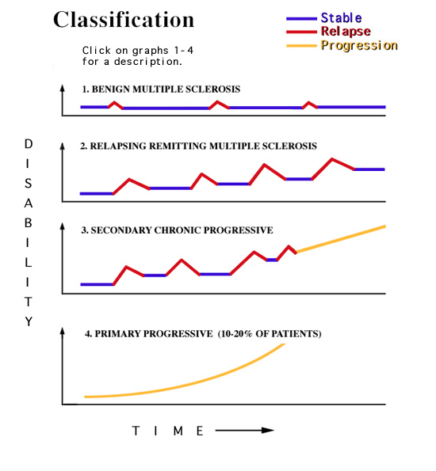
  - Vision: optic neuritis (→ vision loss), nystagmus, diploplia
  - Motor: limb weakness, cerebellar ataxia
  - Sensory: paresthesias, L’Hermitte’s sign (electric shock)
- Dx (current is Poser criteria which only uses hx/sx, no imaging/CSF)
  - Multiple CNS lesions in time and space
  - Mild lymphocytic pleocytosis/oligoclonal bands/elevated MBP in CSF
  - T1 MRI shows ring enhancing lesion
  - NO specific Ab have been identified (but still considered autoimmune)
    - Assoc w/ increased titers to various viral Ag
    - Assoc w/ oligoclonal Ab bands but no identifiable Ag

- Tx
  - Beta-interferons reduce severity and freq of exacerbations
  - Glatiramer (mixture of amino acids) inhibits immune response to MBP
  - Mitoxantrone slows progression but is cardiotoxic
  - Natalizumab (anti alpha4 integrin Ig) reduces freq of exacerbations
    - Can reactivate latent JC virus (causes fatal PML)
  - No significant response to most immunosuppressive therapies

PATHOLOGY OF NEUROMUSCULAR DISEASE
- Neuromuscular components
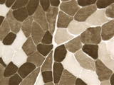
  - Skeletal muscle structure
    - Myocytes are composed of many myofibrils (chains of sarcomeres) w/ eccentric nuclei
    - Connective tissue wrappings include endomysium, perimysium, epimysium
    - NMJ between motor axon/muscle cell, Ach is major NT secreted by motor end plate
  - Skeletal muscle physiology
    - Innervated by myelinated motor neurons from anterior horn cell in spinal cord
    - Motor unit = motor neuron + all the skeletal muscle cells innervated by it
    - Nerves have trophic effect on muscle (thus denervation leads to atrophy)
    - Two fiber types intermixed → checkerboard appearance
      - Type 1: “red muscle”, sustained work, oxidative metabolism via lipids, lots of mito/capillaries
      - Type 2: “white muscle”, sporadic work, glycolytic metabolism via glycogen, few mitochocapillaries
  - Peripheral nerve structure
    - Bundles of myelinated/unmyelinated motor and sensory fibers
      - α fibers → extrafusal muscle
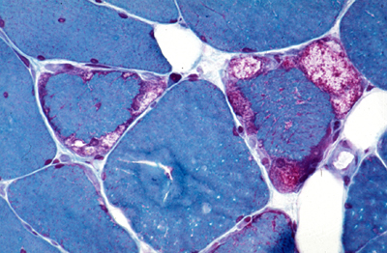
      - γ fibers → intrafusal muscle (stretch reflex)
      - Aα/Aβ/Aδ fibers are sensory
    - Connective tissue wrappings include endoneurium, perineurium, epineurium
    - Schwann cells myelinate ONE axon, internodes w/ saltatory conduction
  - Peripheral nerve physiology
    - Denervation → LMN syndrome = flaccid paralysis, hyporeflexia, atrophy
- Neuropathy → skeletal m dysfxn due to loss of innervation (see ALS, autoimmune lecture)
  - Pathology: Wallerian degen, dying back degen, segmental demyelination (onion bulbs in CIDP)
- Myopathy → skeletal m dysfxn due to direct myocyte injury
  - Pathology: myofiber necrosis, ragged red fibers (increased mito), basophilic fibers (regen), inflamm, fibrosis

CLINICAL NEUROMUSCULAR DISEASE
- Distal weakness > proximal + sensory loss + hyporeflexia, think neuropathy
- Proximal weakness > distal + myalgias (w/ myositis) + intact sensation/reflexes, think myopathy
- Neuropathy
  - Acquired: asymmetric
    - Autoimmune neuropathies (see autoimmune lecture)
    - Diabetic neuropathy (most common)
    - Endocrine neuropathy
    - Infections (HIV, HepC, Lyme)
    - Toxic neuropathy (meds, EtOH, Pb)
    - Nutritional neuropathy (B vits)
  - Hereditary: symmetric w/ all limbs involved, slowly progressing
    - Demyelinating: Charcot Marie Tooth I, III, IV
    - Axonal: CMT II, V, VI + hereditary sensory neuropathies (HSN) I-V
  - Neuropathy Evaluation: genetic testing, labs, EMG/NCS for demyelination & F-waves, nerve biopsy
- Myopathy
  - Endocrine: common in Cushing’s
  - Metabolic: GSD (McArdles/Pompes) & mito disorders (see elevations in serum lactate due to anaerobic metabolism)
  - Toxic
    - Myopathy w/ neuropathy: statins
    - Myopathy w/cardiomyopathy + neuropathy: colchicine (gout)
  - Periodic paralysis
    - HyperK periodic paralysis due to Na channel mutations
    - HypoK periodic paralysis due to Ca channel mutations
    - Myotonia
  - Myositis: inflamm of muscle → progressive weakness w/ pain + elevated CK
    - Due to infxn, drugs, auto-immune (PM/DM, see autoimmune lecture)
  - Dystrophies: genetic, progressive myopathies
    - Duchennes: X-linked mutation → lack of dystrophin → difficulty standing, wheelchair by 12, death by 30
      - Beckers is a decrease in dystrophin w/ similar but less severe clinical picture
    - Facioscapulohumeral: autosomal dominant → weakness in shoulder girdle in 20s
    - Oculopharyngeal: autosomal dominant → dysphagia/ptosis in 50s, common in Fench Canadians
    - Myotonic: autosomal dominant CTG repeat → myotonia, hatchet face, arrhythmias

AMYLOTROPHIC LATERAL SCLEROSIS
- General
  - Idiopathic, lethal, asymetric neurodegenerative dz affecting both UMN/LMN → progressive atrophy and weakness
    - Rare familial form assoc w/ SOD1 mutation (chr 21)
  - Most common form of adult motor neuron disease
  - Affects men/women equally, age of onset peaks in 6th decade
  - Spinal Muscle Atrophy (SMA) is autosomal recessive ALS-like dz in children, assoc w/ loss of SMN1 gene (chr 5)
    - SMA1: infantile, aka Werdnig-Hoffman
    - SMA2: intermediate form
    - SMA3: juvenile, aka Wohlfart-Kugelberg-Welander
- Clinical
  - UMN sx: hypertonia (despite weakness), hyperreflexia, +Babinski
    - MRI is normal, which rules out SC/brain lesions
  - LMN sx: muscle atrophy/weakness, fasiculations
    - Nerve conduction shows…
      - Reduced amplitude (indicates motor axonal loss)
      - Normal velocity (no demylination), normal F-wave (not a root problem), normal latency (not a sensory problem)
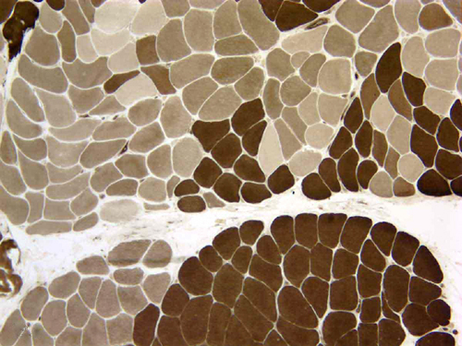
    - Needle EMG shows…
      - Fasciculations at rest (indicates denervation)
      - Polyphasic w/ movement (indicates devervation followed by some reinnervation)
  - NO cognitive, sensory, cranial nerve, or sphincter problems
- Pathology
  - UMN loss → degeneration of pyrimidal tracts, Betz cells of primary motor cortex
    - Assoc w/ gliosis (GFAP stain), Bunina bodies (eosinophilic inclusions),
  - LMN loss → degeneration of anterior horn cells/ventral root, neurogenic atrophy of muscle
    - Early Δs: myofiber atrophy (variable diameters) + EMG fibrillations
    - Mid Δs: fiber type grouping (loss of checkerboard) +  EMG amplitude (re-inn by surviving, i.e.  size motor unit)
    - Late Δs: fibrofatty atrophy +  EMG amplitude (group atrophy, i.e.  # motor units)
- Tx
  - Riluzole slightly improves life expectancy and QOL
  - W/o tracheostomy or ventilation support, life expectancy is <2 years after bulbar involvement
  - With predominantly spinal involvement, 5 year survival is <20%

COGNITIVE DYSFXN
- Definitions
  - Aphasia: inability to understand and use language
  - Anomia: inability to name (word finding difficulty)
  - Agraphia: inability to write
  - Alexia: inability to read
  - Acalculia: inability to calculate
  - Agnosia: failure to recognize perceived stimuli
  - Anosagnosia: failure to recognize illness (unaware of deficits)
  - Prosopangosia: inability to recognize faces (can recognize parts of faces, ID people by voice)
  - Achromatopsia: loss of color vision (inferior parietal/occipital lobe lesion)
  - Neglect: ignoring one side of the environment
  - Disconnection: inability to transmit info from one area of cortex to another (callostomy → R/L hand disconnected)

APHASIA TYPES | SPEECH | COMPREHENSION | REPETITION | OTHER
Broca’s | Poor | Intact | Poor | Damage to 22
Wernicke’s | Fluent | Poor | Poor | Damage to 44/45
Global | Poor | Poor | Poor
Conduction | Intact | Intact | Poor
Transcortical Motor | Poor | Intact | Intact | Damage anterior to Brocas
Transcortical Sensory | Intact | Poor | Intact | Damage posterior to Wernickes
Echolalia | Poor | Poor | Intact

- Gerstmans syndrome: dominant parietal lobe lesion → tetrad of sx
  - Finger agnosia: cannot name fingers or indicate a finger named for them
  - L-R disorientation: cannot indicate which hand/foot is L vs R
  - Acalculia: inability to carry out calculations, often due to pt mistaking the #s
  - Agraphia: inability to write
- Alexia can be +/- agraphia
  - w/ agraphia is worse, due to lesion in dominant parietal lob
  - w/o agraphia still allows for writing, spelling, comprehension, due to posterior dominant/occipital lobe + splenium of CC
- Amnesia
  - Types of memory: registration (attention span), short-term, long-term
  - Anterograde: can’t form new memories, occurs in Korsakoff’s syndrome
  - Retrograde: can’t remember preformed memories (Ribot’s law – most recent memories are lost first)
  - Amnestic syndrome
    - Usually bilateral limbic system lesions + mix antero/retrograde
    - Common after traumatic brain injury
  - Transient global amnesia (think transient ischemia attack)
    - Benign but acute onset of profound transient anterograde amnesia
    - Full recovery of anterograde memory but leaves a permanent memory gap

DEMENTIA
- Mild cognitive impairment: simple memory complaint (corroborated) w/ intact ADLs + normal cognitive fxn
- Dementia: memory impairment + one of the following w/o delerium
  - Language, judgment, abstract thinking, praxis, constructional abilities, visual recognition
  - Multiple etiologies – Alzheimers is most common (covered below), also due to…
    - Diffuse Lewy body dz
      - Clinical: dementia + motor sx of PD (bradykinesia, cogwheel rigidity, shuffling gait)
      - Pathology: widespread Lewy bodies w/ α-synuclein inclusions → atrophy
    - Vascular dementia
      - Clinical: dementia + step-wise decline in fxn following each vascular event
      - Pathology: multiple infarcts (large or lacunar) → cavitations
    - Frontotemporal dementia (think Pick’s dz)
    - Rapidly progressing dementias (covered in prion lecture)
- Evaluation
  - Labs: CBC & chem7, glucose, BUN/creatine, B12, LFTs, thyroid (Δs in any can cause cognitive impairment unrelated to dementia)
  - Mini-mental status exam
  - Depression screening (often hard to distinguish)

ALZHEIMERS DISEASE
- Epidemiology
  - Most common type of dementia
  - 90% sporadic, 10% familial (earlier onset + faster progression)
  - Risk increases w/ age, insulin resistance, hypercholesteremia
- Clinical features
  - Gradual progression (10yrs) vs stepwise in multiple infarct dementia or undulating in DLBD
    - Early sx: impaired recent memory, depression
    - Late sx: impaired remote memory, poor speech, agitation
    - End-stage sx: complete amnesia, mute
  - Definitive dx is via autopsy, but imaging can complement evaluation
    - MRI: marked reduction in brain volume (frontal & parietal) + hydrocephalus ex vacuo
    - fPET: impaired glucose utilization in posterior cingulate gyrus & parietal cortex (DLBD is anterior)
- Pathologic features
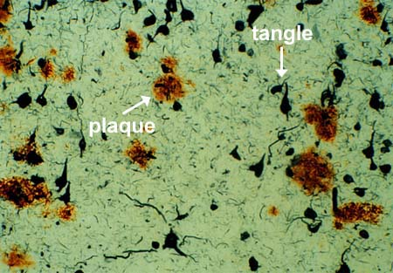
  - Δs that correlate best w/ cognitive fxn are:
    - Severe loss of neurons → gliosis + low brain wt + hydroceph ex vacuo
      - 1˚ hippocampus, entorhinal cortex, parietal/frontal cortex
    - Neurofibrillary tangles: intracell inclusions of hyperphosphorylated tau proteins
    - Senile plaques: accumulation of b-amyloid in neuropil
  - Other Δs: hirano bodies (inclusions), amyloid angiopathy (b-amyloid in vessel walls)
  - Pallor of locus ceruleus (AD is defcy of Ach defcy)
  - Dx criteria: #plaques/HI power field, # needed to dx increases w/ age (>76y=15+)
- Genetics
  - Trisomy 21 (3 copies of APP gene) → early onset AZ
  - Mutated APP gene assoc w/ familial AZ
  - APO E4 allele assoc w/ sporadic AZ
  - Presenilin 1/2 increase Aβ-amyloid
- Pathophysiology
  - Beta/gamma secretases abnormally splice APP into β-amyloids I-40 (vessels)/I-42 (neurons) = non-fxnal and toxic
  - Β-amyloids activate caspases that lead to hyperP of tau (tangles)
    - HyperP is also indirectly caused by insulin resistance via disinhibition of GSK3
- Tx
  - Acetylchoinesterase inhibitors (donepezil, galantamine, rivastigmine) slow progession more than relieve sx
  - NMDA receptor antagonist (memantine)
  - Vit E may slow progression

PRION DISEASE
- Caused by mutations or conformational changes of the prion protein PrP^{c} to PrP^{sc} or to glycated prion protein
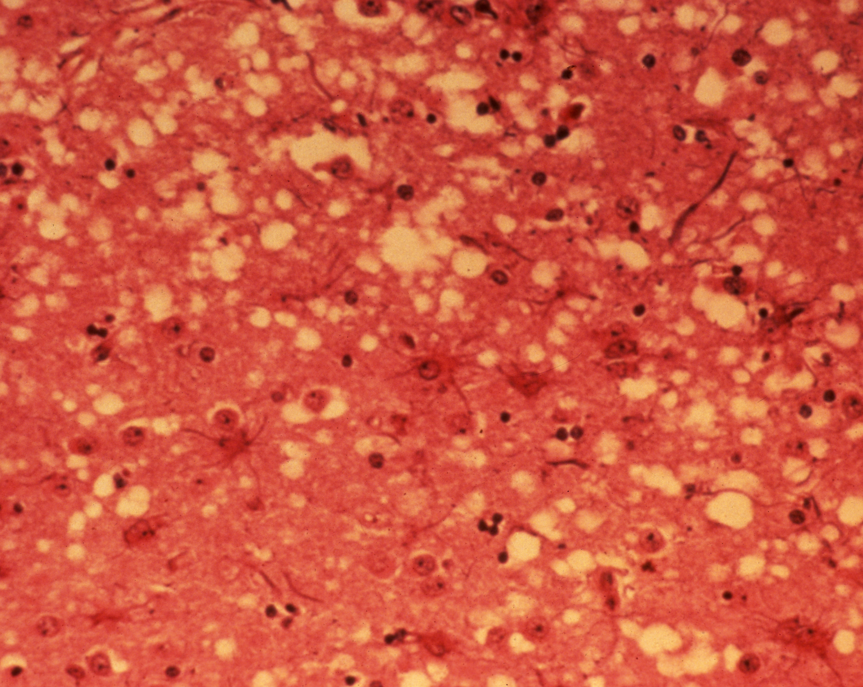
  - Normally PrP^{c} to PrP^{sc} are in equilibrium → unknown trigger → catalytic conversion to pathological form
  - PrP^{SC} → beta sheet conformation, which forms insoluble plaques and causes dz
- Pathology
  - Spongiform degeneration → formation of cytoplasmic vacuoles that are filled PrP^{SC} protein
  - Various types of amyloid plaques
  - Gliosis excessive for degree of neuronal loss
- Types
  - Sporadic CJD: most common, onset 65y, rapidly progressing (<1y), defined by mutation of codon 129 (met/val) of prion gene
    - M/M type 1: occipital/parietal cortex
    - M/M type 2: cerebral cortex (most common)
    - M/V type 2: cerebellum, ataxia precedes dementia, Kuru plaques
    - V/V type 2: thalamus
  - Familial CJD: AD inheritance
  - Gerstmann-Straussler-Scheinker: slower progression than other forms of prion diseases (3-5y)
  - Human BSE: mad cow dz

CLINICAL HEADACHE
- Most due to VD of intracranial b-vessels → stimulation of surrounding trigeminal nerves (or via increase/decrease ICP, inflamm)
  - There is release of CGRP and also increased pain, the order in which it happens is not yet clear
- Primary types
  - Migraine: neurovascular dz w/ recurring unilateral HA, pulsating quality, assoc w/ nausea, photo/phonophobia, family hx common
    - Can occur w/ aura = visual/sensory sx that develop gradually before HA onset, reversible
  - Tension: diffuse squeezing sensation, can become chronic w/ chronic NSAID use (aka medication misuse HA)
  - Cluster: M>>F, excruciating “hot poker” pain behind one eye assoc w/ ptosis/miosis/lacrimation, lasts 45m w/ ~3 HA/2mo cluster
- Secondary types
  - Pseudotumor cerebri: 30y obese F, sx of increased ICP w/o hydrocephalus (esp papilloedema, HA, vision Δs), tx wt loss
  - Trigeminal neuralgia: brief, severe pain in CNVII dist’b elicited by touch/chewing, tx carbamezapine
  - Temporal arteritis: >60y, temporal HA, vision Δs, fever/wt loss, elevated ESR, vasculitis on biopsy, tx prednisone
- Common associations
  - “Thunderclap” first & worst HA = SAH, get a CT/LP
  - Warning sign of increased ICP is HA that awakens pt (b/c hypoventilate when sleeping → increase CO2 & compensatory VD)
  - Palpable tender temporal arteries w/ vision changes = giant cell (temporal) arteritis, get an ESR
  - Cherry-red w/ HA in wintertime = CO poisoning
  - ALL headaches can cause N/V

HEADACHE PHARMACOLOGY
- Primary headache: tension, migraine, cluster (=CDH if >15/mo)
- Neurovascular hypothesis: belief is that HA is due to vasodilation – trigeminal n innervate cranial blood vessels, sensitization of vessels (due to stress, noise, etc) → release of inflammatory mediators (CGRT/substance P) which cause VD (this is diff than Dr. George??)
  - 5HT agonists prevent mediator release → VC
- HA assoc with N/V and decreased GI emptying will impact drug absorption
- Acute vs prophylactic tx
  - Use acute during the HA, the sooner the better
    - Tension: acetaminophen, NSAIDS
    - Migraine: triptans
    - Cluster: O2
  - Use prophylaxis when HA are frequent (>2/wk), severe, or have contra to acute drugs
    - Tension: amitriptyline
    - Migraine: beta-blockers, topiramate
    - Cluster: prednisone, verapamil
- Drug-induced (medication misuse) headache
  - CDH due to overuse of HA meds → hyperalgesia, usually due to OTC analgesics (acetaminophen, caffeine, ASA), tx is d/c drug
- Headaches in women
  - Menstruation → HA due to fluctuation of estrogen levels, thus tx w/ birth control or NSAID mini-prophylaxis
  - In pregnancy, NO triptans/ergots

ACUTE TREATMENT
DRUG | MOA | SIDE EFFECTS
Ergot Alkaloids | 5-HT/DA R agonist → VC | Peripheral VC → numbness, muscle pain, gangrene  DA activation → N/V  Contra: vascular dz, pregnancy, concomitant use w/ triptans
Triptans  Sumatriptan | 5-HT R agonist → VC | Well tolerated w/ less nausea + “triptan sx” (tingling, lethargy, chest tightening)  Contra: vascular dz, pregnancy, concomitant use w/ ergots or MAOI
Acetaminophen | Not an NSAID, but close | Safest of all tx
NSAIDS/ASA | (-) prostaglandins | Safe, can → GI bleeding
Caffeine | → VC | Safe, can → caffeineism, assoc w/ withdrawal Has (tx is reintroduction)
Metoclopramide | Anti-emetic via DA antag | Safe, DOC for nausea in migraine
Opiods |  | Abuse potential

PROPHYLACTIC TREATMENT
DRUG | MOA | SIDE EFFECTS
Tricyclics  amitriptyline | Unknown | DOC for tension HA prophylaxis  Anticholinergic SE (drying, constipation)  Contra: pregnancy, concomitant use w/ MAOIs
B-blockers  propranalol | Unknown | DOC for migraine HA prophylaxis, double dip w/ heart dz  Antiadrenergic SE (bradycardia, hypoTN)  Contra: asthma
Topiramate | Not given | Migraine HA prophylaxis  Can → cognitive dysfxn, wt loss
Verapamil | Not given | DOC for cluster and migraine HA prophylaxis, double dip w/ heart dz
Valproic acid | Not given | Cluster and migraine HA prophylaxis, double dip w/ seizures or bipolar disorder
Lithium | Enhances 5HT transmission | Cluster HA prophylaxis, double dip w/ bipolar disorder  Contra: pregnancy, plus it sucks to take it

NEUROPATHIC PAIN
- Pathophysiology
  - Nociceptive pain is via damage to tissue (protective)
    - Quality is “throbbing,” responds to NSAIDS/opiods
    - Normally, NE/5HT/GABA inhibit excitatory pain impulses, which dampens the sensation of pain
  - Neuropathic pain is via direct neuronal injury (no purpose) → pathologic change in the nerve to promote pain
    - Quality is “electric”, refractory to conventional analgesics, both +/- sx (cold, numb, asleep, crawling)
    - Most types have both both central/peripheral pain due to hyper-excitability of neurons
      - Central: loss of GABA inhibition OR enhanced glutamate excitation promote sensation of pain
      - Peripheral: oversensitization of peripheral nerves due to increase in # of Na channels promotes pain
- Types
  - Diabetic neuropathy
    - Burning, tingling bilateral sensation in extremities → loss of sensation → foot ulcers/amputation
    - Tight glucose control has shown efficacy in preventing microvascular complications
    - DOC: pregabalin, gabapentin, duloxetine, tramadol, TCA, opiods
  - Post-herpetic neuralgia
    - Complication of shingles (herpes zoster) most common in elderly
    - Promising vaccine
    - DOC: gabapentin, pregabalin, tramadol, lidocaine patch, opiods
  - Trigeminal neuralgia
    - Compression & demyelination of 5th cranial nerve, most common in MS
    - DOC: carbamezapine (or oxacarbazepine)
  - Drug-induced
    - Blood-nerve barrier is weaker than BBB, thus drugs can cross easier & cause toxicity
      - Cancer chemotherapy (80% of pts) disrupts axonal transport/decrease myelin
      - Antiretrovirals + HIV itself causes neuropathy
      - Isoniazid, tho this can be prevented w/ supplemental B6
    - Distal axons affected first, followed by Wallerian degen, obvi not helpful
    - DOC: pretty much anything
- Strategies to treat neuropathic pain
  - Start low, go slow
  - Everyone is different, choice is specific to patient and should account for DDI, co-morbities, SE, etc

(More info on the AEDs in next section)
DRUG | MOA | INDICATION | ADVERSE EFFECTS
Gabapentin | Ca channel blocker | All | none
Pregabalin | Ca channel blocker | All | none
Carbamazepine  Oxcarbazepine | Na channel blocker | Trigeminal neuralgia | Inducer, SIADH, rash (→SJ)  Oxy not metab to 10-11 epox intermediate = less SE
Lidocaine | Na channel blocker | Post-herpetic | Only for post herpes, never put on open lesion
Amitriptyline (TCA) | NE/5HT reuptake inhibitor | Diabetic, drug-induced | DO NOT use if arrhythmias, seizures, MAOIs
Duloxetine (SSRI) | NE/5HT reuptake inhibitor | All | DO NOT use if MAOI
Opiods | Unknown (for NP) | All | Constipation (stool softener + stimulant), resp depression
Topiramate | Na channel blocker |  | Wt loss, kidney stones
Valproic Acid | Unknown |  | Inhibitor, THBpenia, hepatotox, wt gain, alopecia
Tramadol | NE/5HT reuptake inhibitor | Diabetic neuropathy | DO NOT use if seizures
Capsaicin | substance P depletion | Only in combination | Don’t smear all over your hands and then rub your eyes

SEIZURES
- International Classification of Epileptic Seizures: recurrent unprovoked seizures due to transient, hypersynchronous, electrical activity
  - Automatisms: stereotypic repetitive/automatic motor or vocal behaviors (ex) rubbing, squeezing, picking, lip-smacking
    - Most common in complex partial and absence seizures
  - Aura: sensation experienced by some people before an impending complex partial seizure, essentially a simple partial seizure
  - Most important is the correct classification, since tx can differ
    - (ex) Phenytoin/Carbamezapine are 1st line for tonic-clonic but will make absence/myotonic/atonic worse
- Partial seizures (may progress to a secondarily generalized seizure)
  - Simple: consciousness intact
    - Sx: contralateral motor/sensory (+/- march), autonomic (abd aura, sweating), psychic (déjà vu, intense fear)
  - Complex: consciousness impaired, assoc w/ automatisms & aura, ictal amnesia + post-ictal confusion
    - Sx: above + able to respond in a limited way (ex: doesn’t seem to recognize name when called, but turns toward noise)
- Generalized seizures
  - Absence: momentary LOC (spontaneously becomes “absent”), transient spike/wave activity, no post-ictal confusion, 1˚ children
  - Tonic-Clonic: LOC + convulsions, profound post-ictal confusion
    - Tonic phase first - all muscles contract, fall to ground, arms/legs extended & rigid, bites tongue, no breathing
    - Clonic phase follows - rhythmic jerking
  - Myoclonic: consciousness appears preserved + sudden shock-like contraction of head/UL, <1s long, common w/ awakening
  - Atonic: brief impairment of consciousness + sudden loss of tone in postural muscles → fall, no post-ictal (hop right back up)
    - Frequent falls can result in injury, think young kids in helmet
- Status Epilecticus: 2+ seizures w/o regaining consciousness, life-threatening

- Etiology
  - Childhood: perinatal injury, congenital defects
  - Adolescence: idiopathic
  - Early adulthood: trauma, idiopathic, drugs/EtOH
  - Late adulthood: brain tumor, vascular diseases, degenerative diseases (like AD)
- Tx
  - Goal is to maintain normal lifestyle with complete seizure control and no side effects (possible in 65% of pts)
  - Always initiate w/ single drug (preferably non-sedating), monotherapy is the rule!
  - Valproic acid is used for all types of seizures, CBZ/PHY are 1st line for partial/tonic-clonic, ethosuximide is used for absence

SEIZURE PHARM
- Goal is to reduce seizure spread via
  - Blocking Na/Ca channels, which keeps cells refractory to AP by preventing Na/Ca influx
  - Enhancing inhibitory (GABA) via increased synthesis or R agonist (which hyperpolarizes cell due to Cl influx)
  - Decreasing excitatory (NMDA) via R antagonists
- Traditional drugs (PHT, CBZ, VPA, PHB, BZO, ETH) tend to have more side effects, but also more data
  - Serious SE include teratogenesis, blood dyscrasias (check baseline), osteoporosis
- Clinical pearls
  - MAJOR inducers: phenytoin, carbamazepine, phenobarb
    - Inducers will decrease [] of those drugs metab by CYP, this happens slowly
    - CBZ also induces own metabolism = initially therapeutic but then levels drop off due to autoinduction → increase dose
  - MAJOR inhibitors: valproic acid
    - Inhibitors will increase the [] of those drugs metab by CYP, this happens immediately
  - PHT undergoes non-linear metab (ex of hot dog line @ halftime) so increase dose slowly
  - PHT is 90% protein bound so only free [] is clinically useful
    - Δs in protein binding (renal/hepatic dz, preg, burns, trauma, inflamm) → Δs in free []
  - Best scenario is to d/c AED if pregnant + folate, otherwise monotherapy

DRUG | MOA | ADVERSE EFFECTS
Phenytoin | Na channel blocker | acne, hirsutism, nystagmus, gingival hyperplasia
Carbamazepine | Na channel blocker | SIADH, rash, hirsutism
Valproic Acid | Na/Ca block, +GABA | rash (can → Stevens-Johnson syndrome!), THBcytopenia, hepatotox, wt gain, alopecia
Phenobarbital | +GABA | rash
Benzodiazepine | +GABA
Ethosuximide | Ca channel blocker
Lamotrigine | Na channel blocker | rash (can also → Stevens-Johnson Syndrome, NEVER use w/ VPA!!), aplastic anemia
Oxcarbazepine | Na channel blocker | SIADH
Topiramate | Na, +GABA, -NMDA | wt loss, kidney stones
Zonisamide | Na/Ca blocker | kidney stones

EYE MOVEMENTS/DIZZINESS
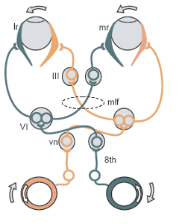
- 3 types of neurologic dizziness
  - Vertigo: illusion of mvmt when stationary
  - Dysequilibrium: imbalance when standing/walking
  - Presyncope: lightheadness, graying vision
- Goal is to always keep object centered on fovea, thus there are many reflexes to maintain this
  - Vestibular: holds images steady during brief mvmt (ex) driving on bumpy road
  - Nystagmus: quick phase is normal, as it resets the eye back toward visual cue
  - Vestibulo-ocular: involves CNVIII, CNVI, CNIII, MLF to keep eyes fixed when head rotates
    - Oscillopsia = loss of VOR
- Bedside tests
  - Calorics: COWS CUWD is normal, lack of nystagmus indicates problem w/ vestibular system
  - Hallpike Dix: provokes nystagmus in BBPV by stirring up endolymph in semi-circular canals
    - Rotate head 45˚ and extend neck, quickly move pt from sitting to supine and back
    - +HD will cause vertical nystagmus w/ gaze away from lower ear, torsional w/ gaze toward

 | CENTRAL (brainstem/vestibular n) | PERIPHERAL (CNVIII, canals)
Nystagmus direction | Single direction | Both horizontal and vertical
Fixation | Does NOT suppress nystagmus | Suppresses nystagmus
Gaze | No change | Nystagmus increases w/ gaze toward quick phase side
Calorics | Increases nystagmus | Little change
Balance | Severe problem, unable to tandem, +Romberg | Mild problem, poor tandem, -Romberg
Other | No hearing loss/tinnitus | Assoc hearing loss/tinnitus

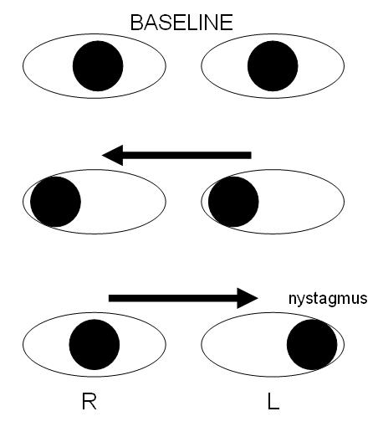
- Intranuclear opthalmoplegia: diploplia/vertigo due to non-conjugate lateral gaze
  - Due to destruction of MLF (tract from abducens nuclei to contralateral oculomotor nuclei)
  - → inability to adduct affected eye + physiologic nystagmus in unaffected eye
  - Ex: loss of R MLF → no R adduction + nystagmus in L eye due to diploplia (shown in picture at right)
- Episodic Dizziness <1m = BPPV
  - Loose otoconia affect endolymph flow → dizziness, often in posterior canal
  - Dx: nystagmus w/ Hallpike-Dix maneuver
  - Tx: Epley maneuver to get junk out
- Dizziness <1h = TIAs, migraine, panic attacks
- Dizziness >1d = Meniere’s dz
  - Episodic increase in endolymph pressure → fluctuating low frequency hearing loss
- Acute vertigo (1-3d) tx w/ vestibular suppressants (diazepam/droperidol) + antiemetics + bed rest
  - If >3d stop vestibular suppressants

COMA
- Total lack of consciousness – no response to sound/light/pain, no sleep/wake cycles, no voluntary movements
- Etiology: damage to RAS, hemorrhage/infarct, hypoxia, trauma, herniation, metabolic (aka diffuse damage)
- Clinical signs
  - Respirations
    - Lesions at various levels of brainstem are characterized by different pathological breathing patterns
    - Cheyne-Stokes: crescendo-decrescendo
  - Pupils
    - Pinpoint fixed = pons
    - Large fixed = midbrain
    - Unilateral dilated w/ third n palsy = compressed CNIII, often due to uncal herniation
    - Small pupils w/ Horner’s syndrome = lesion in sympathetic pathway (hypothal)
    - Pupillary light reflex is intact w/ metabolic coma, thus most impt sign distinguishing it from structural coma
  - Vestibular reflexes
    - +VOR (not conscious to fix on object but eyes do anyways), aka “doll’s eyes”
    - Fast phase of nystagmus is via cerebrum (so absent in coma) → eyes move toward (cold) or away (warm) from ear
      - If both phases are absent, then brainstem is also damaged = very poor px
  - Persistant vegetative state: “worsening” of coma but NOT brain death as brainstem is still alive
    - Sleep-wake cycles present
    - No purposeful response to stimuli, tho may open eyes, track mvmts, cry, grunt, etc (this is spontaneous)
    - PVS pt is kept alive by their fxn’ing brainstem, a brain dead pt is kept alive strictly by life support
  - Uncal Herniation
    - Respiration: normal to Cheyne-Stokes
    - Pupils lack direct reflex, dilated on affected side
    - Oculocephalics: Doll’s eyes
    - Calorics: 3rd nerve paralysis prevents contralateral adduction (eye won’t cross midline)
    - Response to pain: reflexive only on ipsilateral side
    - Babinski: + contralaterally
- GCS: objective way of recording pts conscious state based on eye/verbal/motor responses (3=brain death, <8=severe coma, 15=normal)

SLEEP
- Sleep stages
  - Stage 2: spindles & K-complexes
  - Stage 3 & 4: delta (slow-wave) sleep
- Waking areas = reticular formation, posterior hypothalamus vs sleep-inducing areas = preoptic nuclei, anterior hypothalamus
- Narcolepsy
  - Associated with decreased hypocretin (important hypothalamic protein assoc w/ arousal) + HLA DBQ602 genotype
  - Sx
    - Excessive daytime sleepiness: daytime napping may be physically irresistible
    - Cataplexy: REM related phenomenon, lose muscle tone but not consciousness, triggered by emotions
    - Sleep paralysis, fragmented sleep, hypnagogic (dreamlike) hallucinations common
  - Dx
    - EDS >3mo + cataplexy OR
    - Complaint of EDS + assoc sx (part iii above) + sleep latency <10m + other causes ruled out
  - Tx
    - EDS: structured nighttime sleep/naps, stimulants
      - DA agonists = amphets, methylphenidate
      - Non-DA agonists = modafinil, which activates hypocretin region of hypothalamus
    - Cataplexy: TCAs, SSRIs, Na oxybate
    - Sleep fragmentation: good sleep hygiene
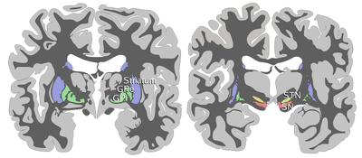
BASAL GANGLIA
- BG circuit involves direct & indirect pathway
  - Input to striatum is via a motor plan from the prefrontal motor cortex
    - Bereitschafts potential: “readiness,” precedes muscular activity
  - Output to primary motor cortex for execution of mvmt is via the thalamus
    - At rest, thalamus is tonically inhibited by (-) GABA from GPi/SNpr
  - BG optimizes the motor program but has no role in the motor decision
  - The ONLY things that release GLU (i.e. are excitatory) are cortex/STN/thalamus
- Disinhibition (two (-) synapses in a row) is how the BG to initiates movement
- Direct (which → mvmt) and indirect pathways (which (-) mvmt)

Cortex (+) Glut Striatum (-) GABA GPi  (-) GABA Thalamus  (+) Glut Cortex

(-) GABA  (+) Glut

GPe STN

 (-) GABA
Direct

Indirect

- Dopamine receptors
  - Dopamine selectively excites the direct pathway and inhibits the indirect pathway
  - D1: acts to excite the striatum
    - DA from SNpc binds striatal D1 → excitation/release of GABA (the normal striatal NT) → inhibtion of GPi/SNpr, etc
  - D2: acts to inhibit the striatum
    - DA from SNpc binds striatal D2 → inhibition/NO release of GABA → excitation (aka loss of inhibition) of GPe
    - This is ok b/c normally, the direct pathway trumps the indirect and the STN is tonically inhibited
- Structure of striatum
  - Striatum = caudate, putamen, globus pallidus (nterna/externa) and nucleus accumbens
  - Inputs to striatum is mostly cortex (tho also important is SNpc via dopamine) + somatotopically organized
  - Striosomes (axons go to D1 R and project to GPi)
    - Substance P and dynorphin
    - Limbic function
  - Matriosome (axons go to D2 R and project to GPe)
    - Enkephalin
    - Sensorimotor system
  - Medium Spiney Neurons (95% of striatum)
    - Abundant spines due to immense amount of input they receive
    - GABAnergic (i.e. intrinsically inhibitory), 3 types based on DA R type
- Convergence occurs, w/ many parallel circuits that never interact – exception: removing DA → more communication btw parallel circuits and thus more convergence
- Hypokinetic disorders
  - Parkinsons: progressive degeneration of the DA neurons from the SNpc means the striatal nuclei fxn w/o DA input
    - Loss of DA on D1 R → NO release of GABA from striatum → GPi no longer inhibited, so it (-) thalamus = NO mvmt
    - Loss of DA on D2 R → release of GABA from striatum → GPe now inhibited, so STN is able to excite GPi further and only exacerbate the problem
    - In other words, the direct pathway is silenced/indirect pathway is hyperactive
- Hyperkinetic disorders
  - Hemiballismus
    - STN is destroyed → NO indirect pathway → NO activation of the GPi/SNr “brake” and hyperactive thalamus
  - Huntingtons
    - Connection btw striatum/GPe is destroyed → NO indirect pathway → same as above

CLINICAL MOVEMENT DISORDERS
- Ballismus: loss of STN (usually unilateral) = no stimulation of GPe/SNpr = no inhibition of thalamus → sudden flinging of entire limb
- Chorea (distal writhing) & athetosis (proximal): loss of indirect pathway → nearly continuous mvmt of 1+ limbs
  - Huntingtons: auto dominant, >30 CAG repeats on chr 4 → loss of D2 output and sx above
  - Sydenhams: post-infxn
  - Toxic: most common is from over-medicated PD
- Dystonia: genetic/idiopathic continuous involuntary contraction of muscle groups → abnormal posture
  - Wilsons disease can → a pediatric generalized dystonia, so always check Cu levels first!
  - Cervical: most common form in adults, idiopathic
  - Toxic: caused by neuroleptic drugs/levodopa → tardive dyskinesia
  - Blepherospam: involuntary closing of eye muscles
  - Writing dystonia: occurs only when writing
  - Tx: L-dopa (kids), botulinum injections (adults, focal), anti-cholinergics (adults, generalized)
- Parkinsons Dz
  - Loss of SNpc = loss of DA at both D1/D2 R in striatum → depressed direct/hyperactive indirect → hypokinesia
  - Sx: unilateral/asymmetric bradykinesia, cogwheel rigidity, resting tremor, postural instability, festination, supranuclear palsy
    - Progressive dz w/ onset 60y, also assoc w/ cognitive changes/depression
  - Path: SNpc degeneration w/ pallor (DA neurons have melanin in them), gliosis, Lewy bodies
  - Etiology: both environmental (toxins) + familial, tho twin studies show little evidence for genetics
    - A-synuclein mutation: autoD, early onset + fast progression + Lewy bodies
    - Parkin gene: autoR, early onset + slow progression + NO Lewy bodies
    - Dysfunction of proteosomal degregation function (via ubiquitin) may damage to SNc
  - Tx: L-dopa is most efficacious but has many motor SE, covered below
- Tremor: regular rhythmic mvmts, classified as fast/slow, pill rolling/flex & ext, postural/resting/intention
  - Essential tremor: fast, postural, bilateral, increases w/ age, tx w/ primidone or thalamic DBS
  - Can be induced by drugs, adrenaline, etc
- Tics: repetitive but irregular (ex) Tourettes = both motor/vocal tics
- Myoconus: sudden, focal but irregular
- Fasiculations: involve motor units, NOT whole muscle (that would be myoclonus)
- Ataxia: sensory/cerebellar lesion → dyscoordination, dysmetria, dysdiadochokinesis

PARKINSONS PHARM
- Goal is to restore balance of dopamine and ACh w/in the CNS, thus main drugs = DA agonists + Ach antagonists
- Tx is symptomatic only, it does not alter the course of the dz
- DA cannot x BBB but L-dopa (a DA precursor) can, once in nerve terminal its → DA by enzyme DDC (also converted peripherally)
  - To prevent periph conversion before L-dopa even gets to the brain, admin w/ carbidopa, a DDC inhibitor (which can’t x BBB)
- Levo/carbidopa is gold std w/ dramatic improvement initially but severe SE after about 5 yrs
  - On-off effect: unpredictable switch from mobility to hypokinesic PD state w/ no relationship to timing of dose.
    - Tx is apomorphine injections, DA agonist
  - Wearing-off: loss of effect near end of dosing interval, relates to plasma [], occurs sooner w/ progression of dz
    - Tx is increasing dosing frequency, DA agonist
  - Dyskinesias: involuntary chorea-like mvmts in nearly all pts after long-term L-dopa use
  - Delayed gastric emptying which → delayed onset response, so best to take on empty stomach
  - B/c of all the unavoidable SE, L-dopa is NOT an intial tx, it should be thought of as a drug of last resort
  - There is some evidence that L-dopa might actually worsen progression due to production of ROS that damage nerve terminals
- DA agonists do not depend on fxn’al presynaptic neurons, do not generate ROS, cause less motor sx, but will eventually need L-dopa
- IN GENERAL, start pt on anti-chol/amantidine, then add DA agonist, then add levi/carbidopa, then add COMT/MAOIs

DRUG | MOA | ADVERSE EFFECTS
L-dopa/Carbidopa  Sinemet |  DA synth in nerve terminal | SE: motor sx, psychiatric sx, O-HTN, N/V  Narrowing therapeutic window/duration of action w/ dz progression  Contra w/ MAOIs
Ergots/Non-ergots  bromocriptin  apomorphine | Direct DA R agonists | 2nd best efficacy after levo/carbadopa  Bromo: D1 antag/D2 ag, contra w/ 3A4(-)/CAD  Apo: D1/D2 ag, triggers “on” in minutes
Entacapone | COMT(-) → less breakdown | Adjunctive therapy
Selegiline | MAO(-) → less breakdown | Adjunctive therapy (probably since such low bioavailability)  Contra w/ TCAs, SSRIs
Anti-AChs | Restores balance, tx tremor | SE: dry mouth, constipation, urinary retention  Initial monotherapy if mild or adjunct if severe
Amantidine |  synaptic DA reuptake | SE: livedo reticularis  Initial monotherapy if mild or adjunct if severe

